# Summary statistics and possible indicators for research on gender disparities in NCD-based and all-cause mortality using GBD data

Jon Minton

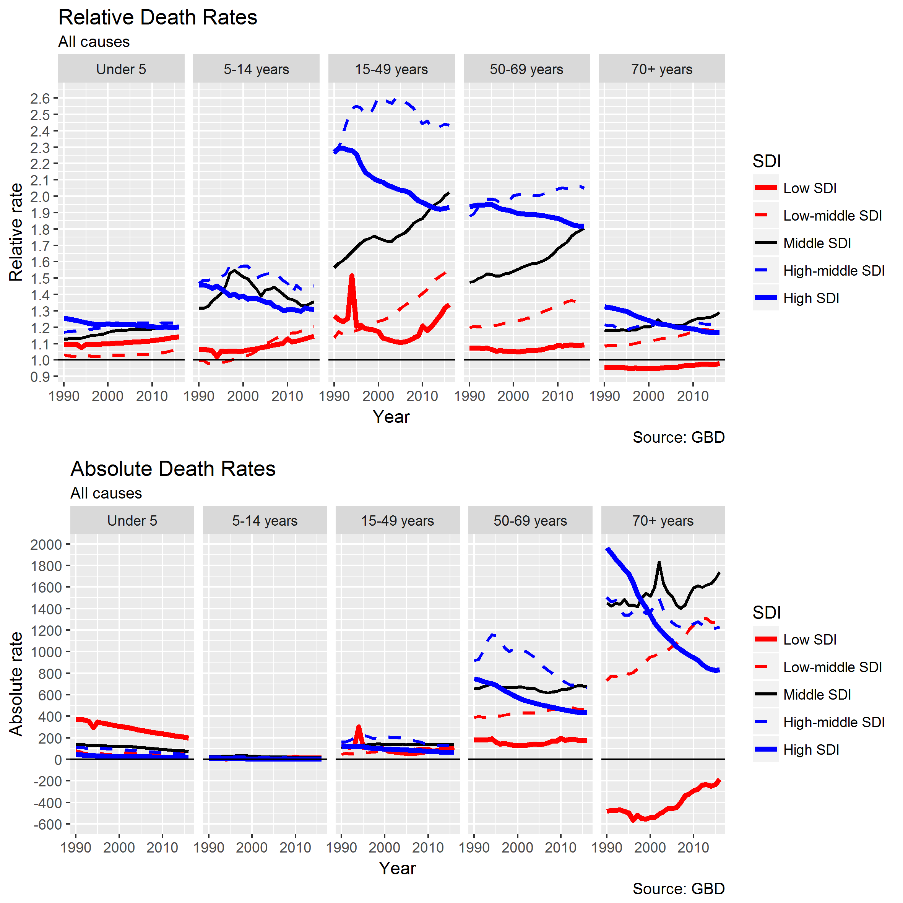

Figure 1 Relative (male / female) and absolute (male – female) death rates by age group and SDI. All causes.

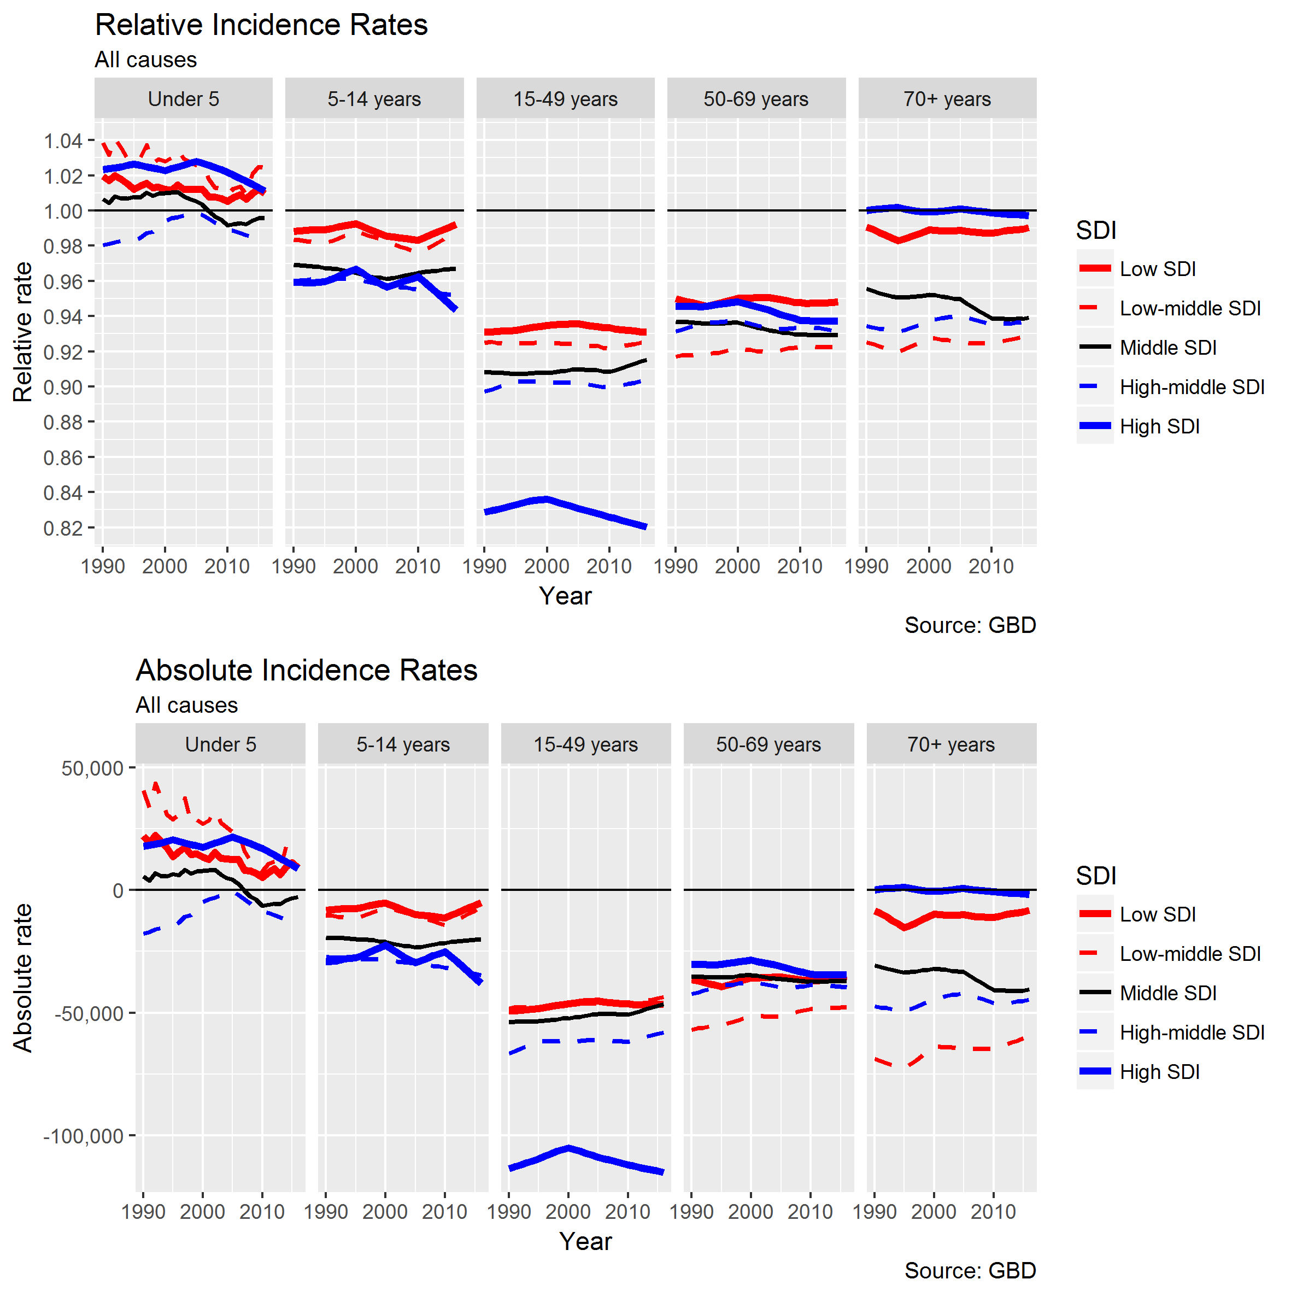

Figure 2 Relative (Male / Female) and absolute (Male - Female) incidence rates, all causes, by age group and SDI

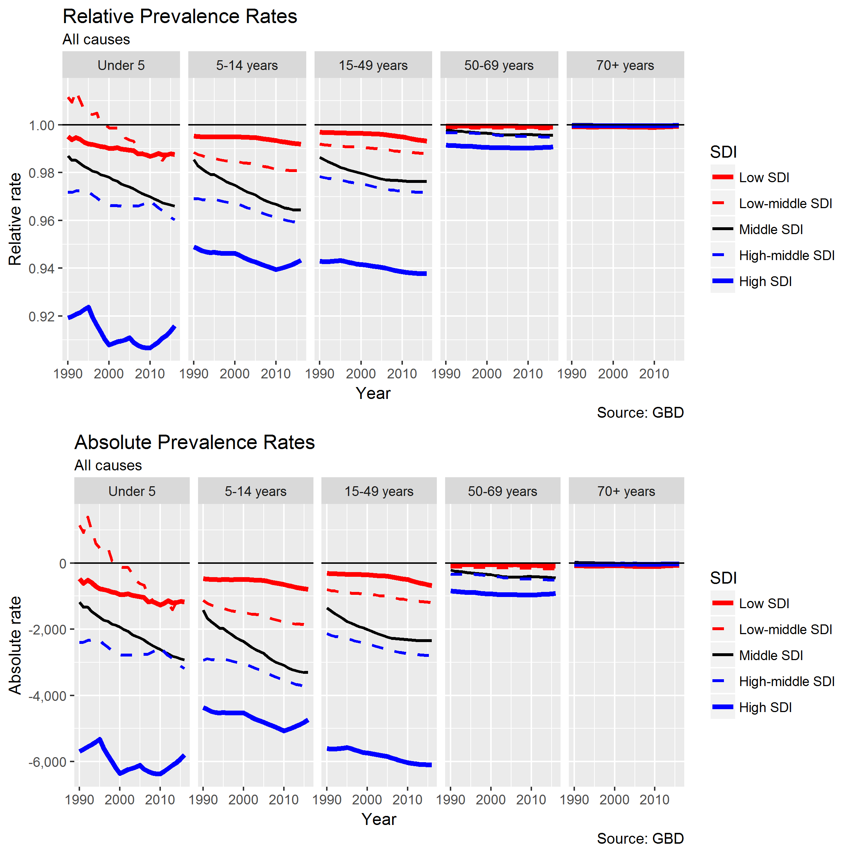

Figure 3 Relative (Male / Female) and Absolute (Male - Female) Prevalence Rates, by age group and SDI, all causes

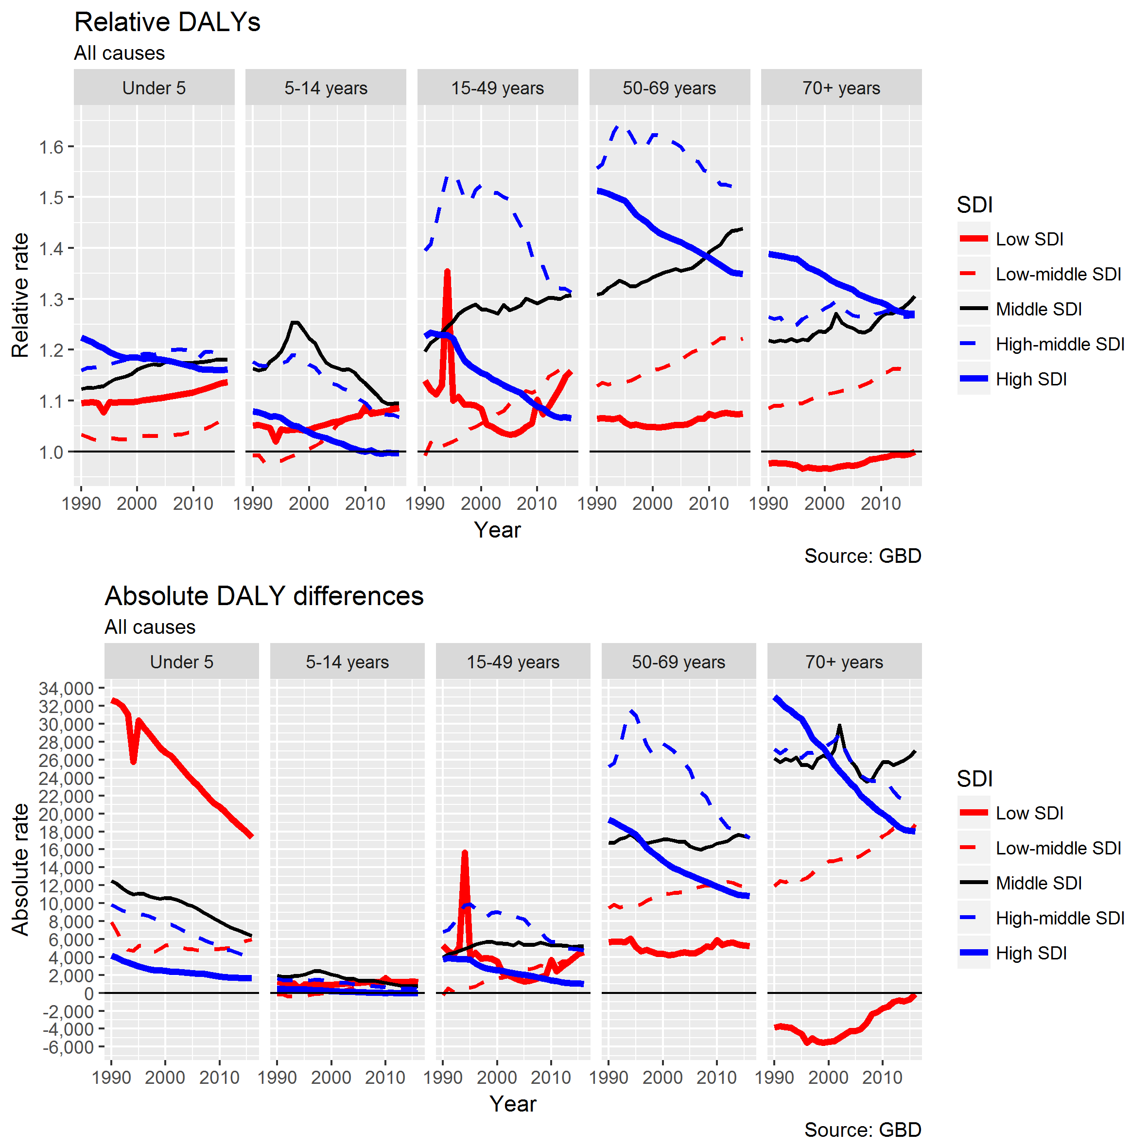

Figure 4 Relative (Male / Female) and Absolute (Male - Female) DALYs, by age group and SDI, all causes

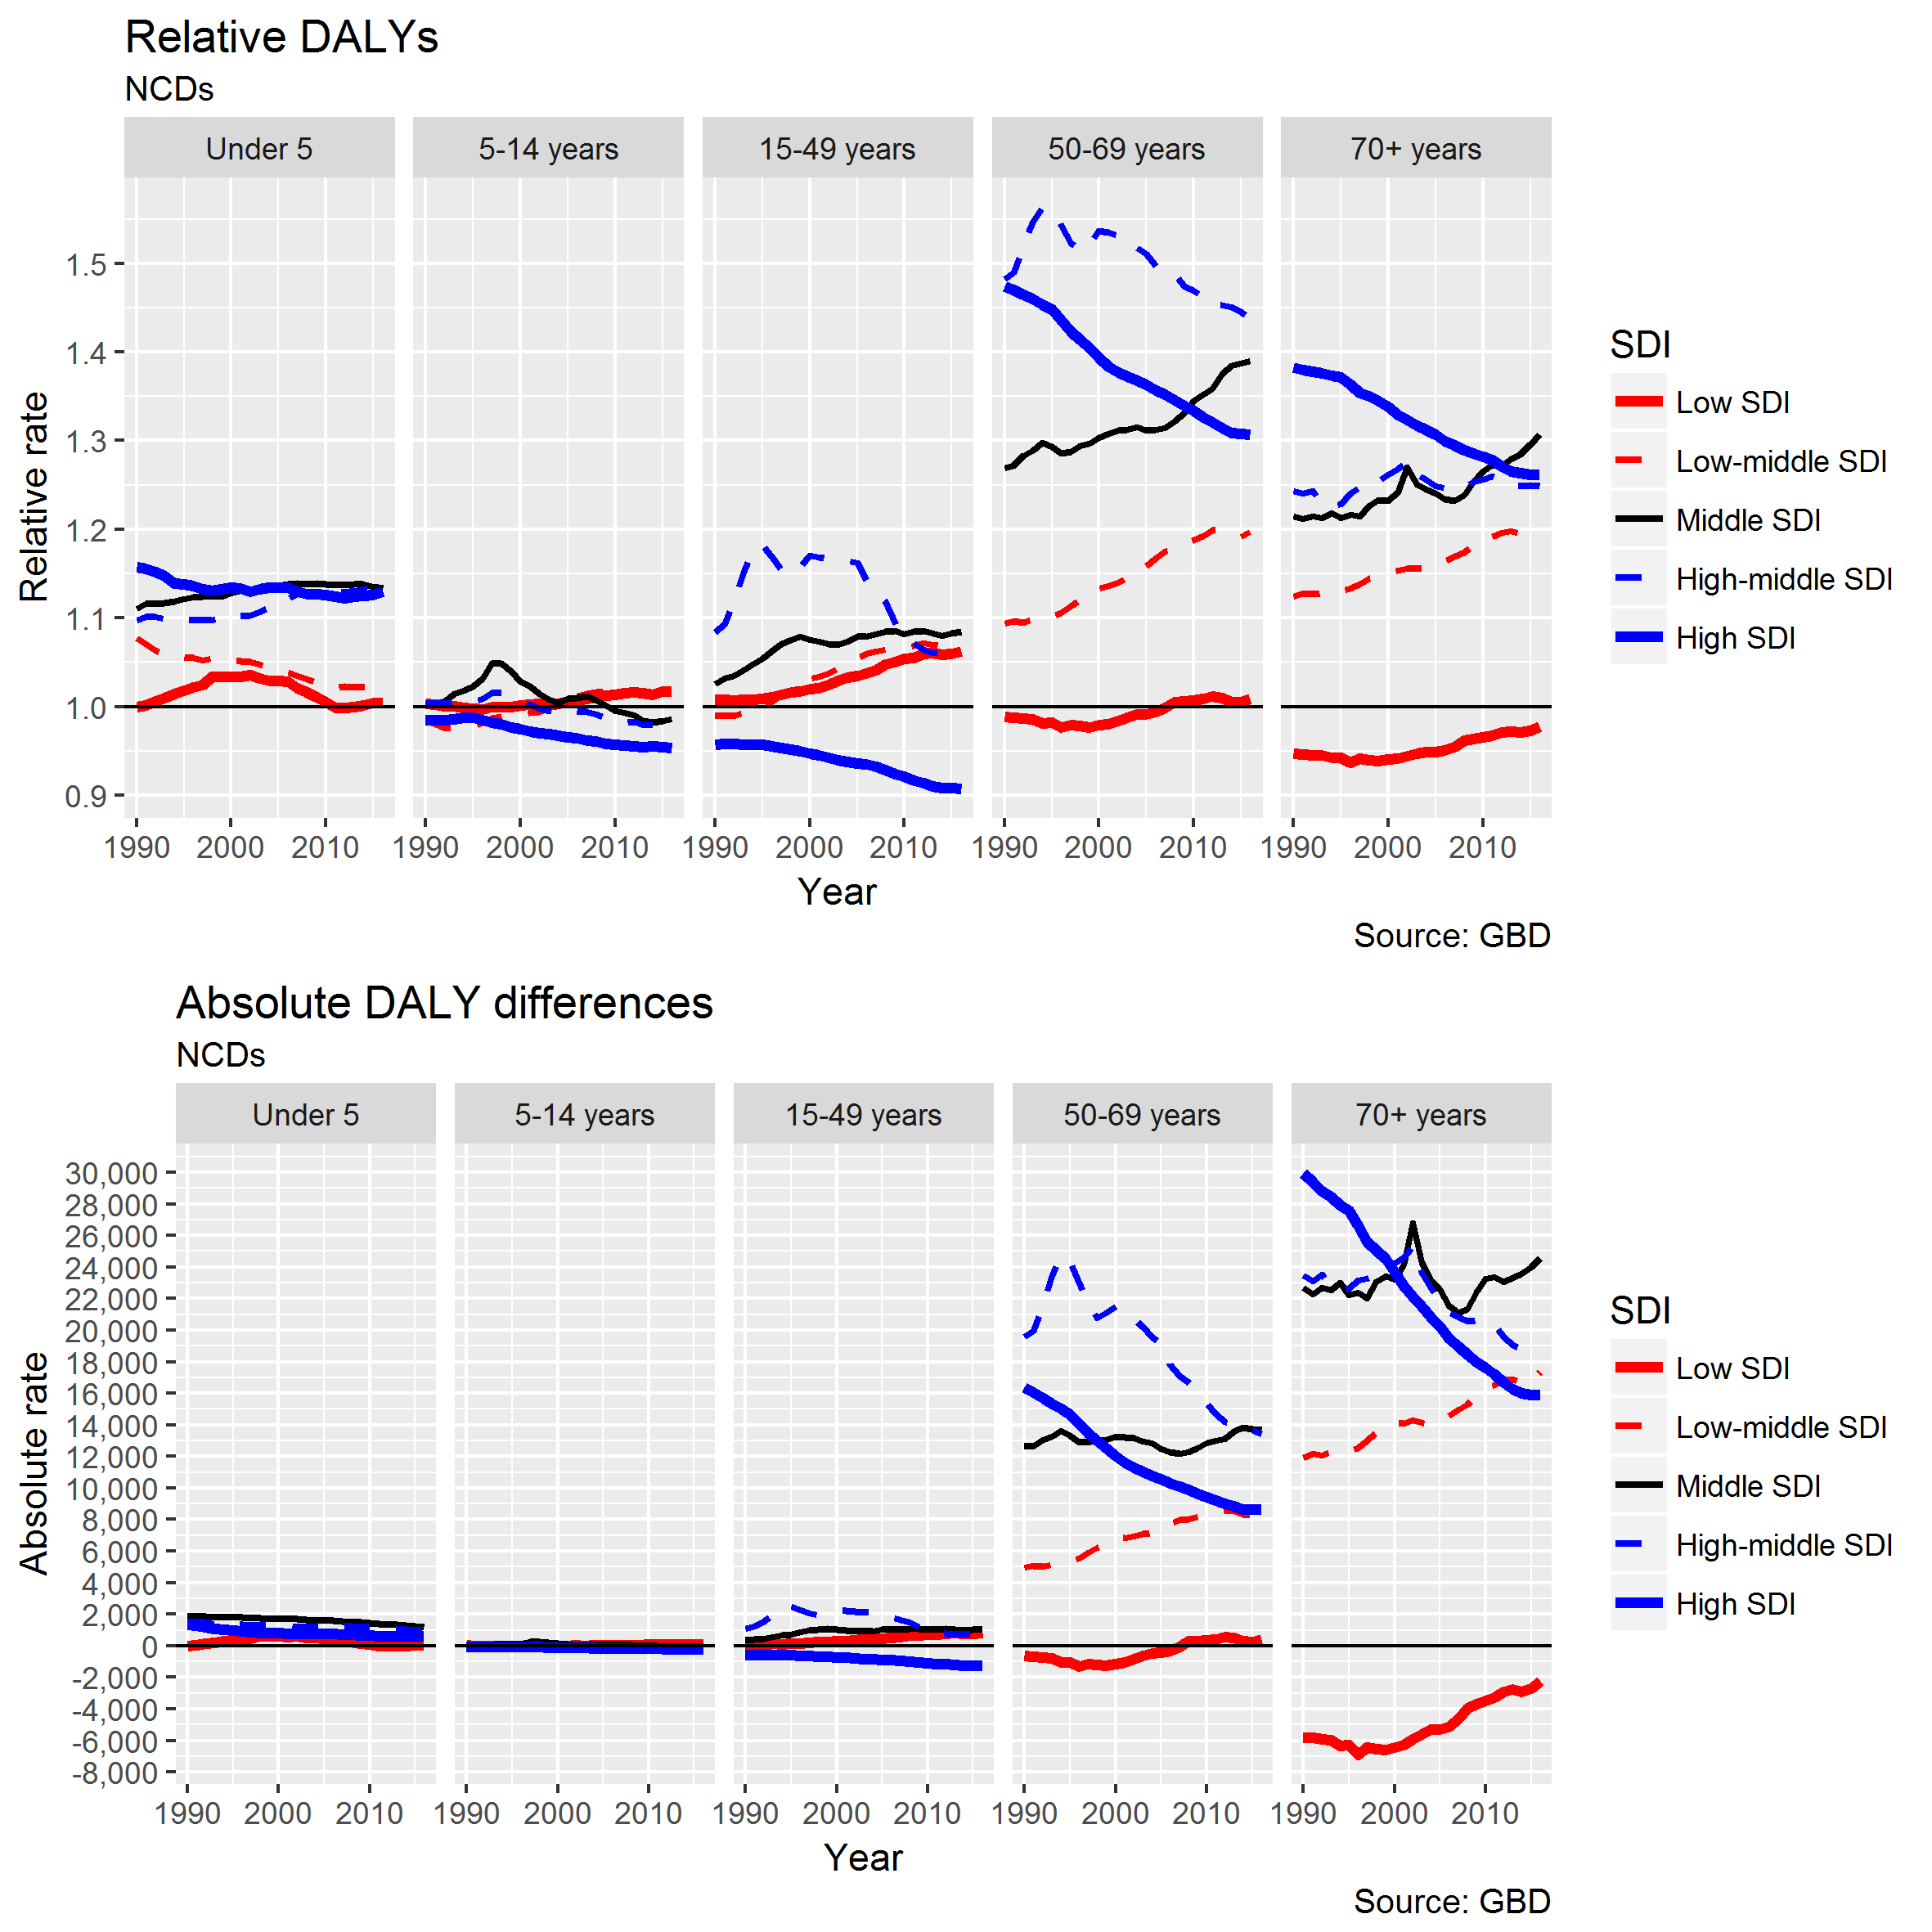

Figure 5 Relative (Male / Female) and Absolute (Male - Female) DALYs, by age group and SDI, from NCDs

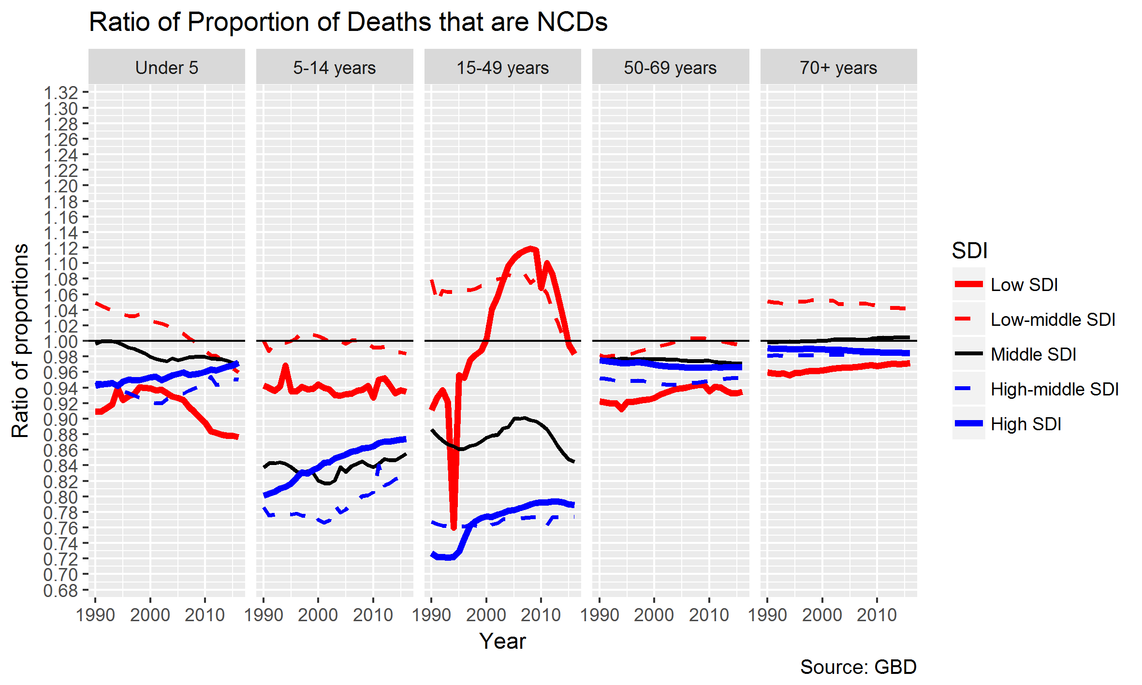

Figure 6 Gender ratio (Male / Female) of proportion of deaths that are due to NCDs, by age group and SDI

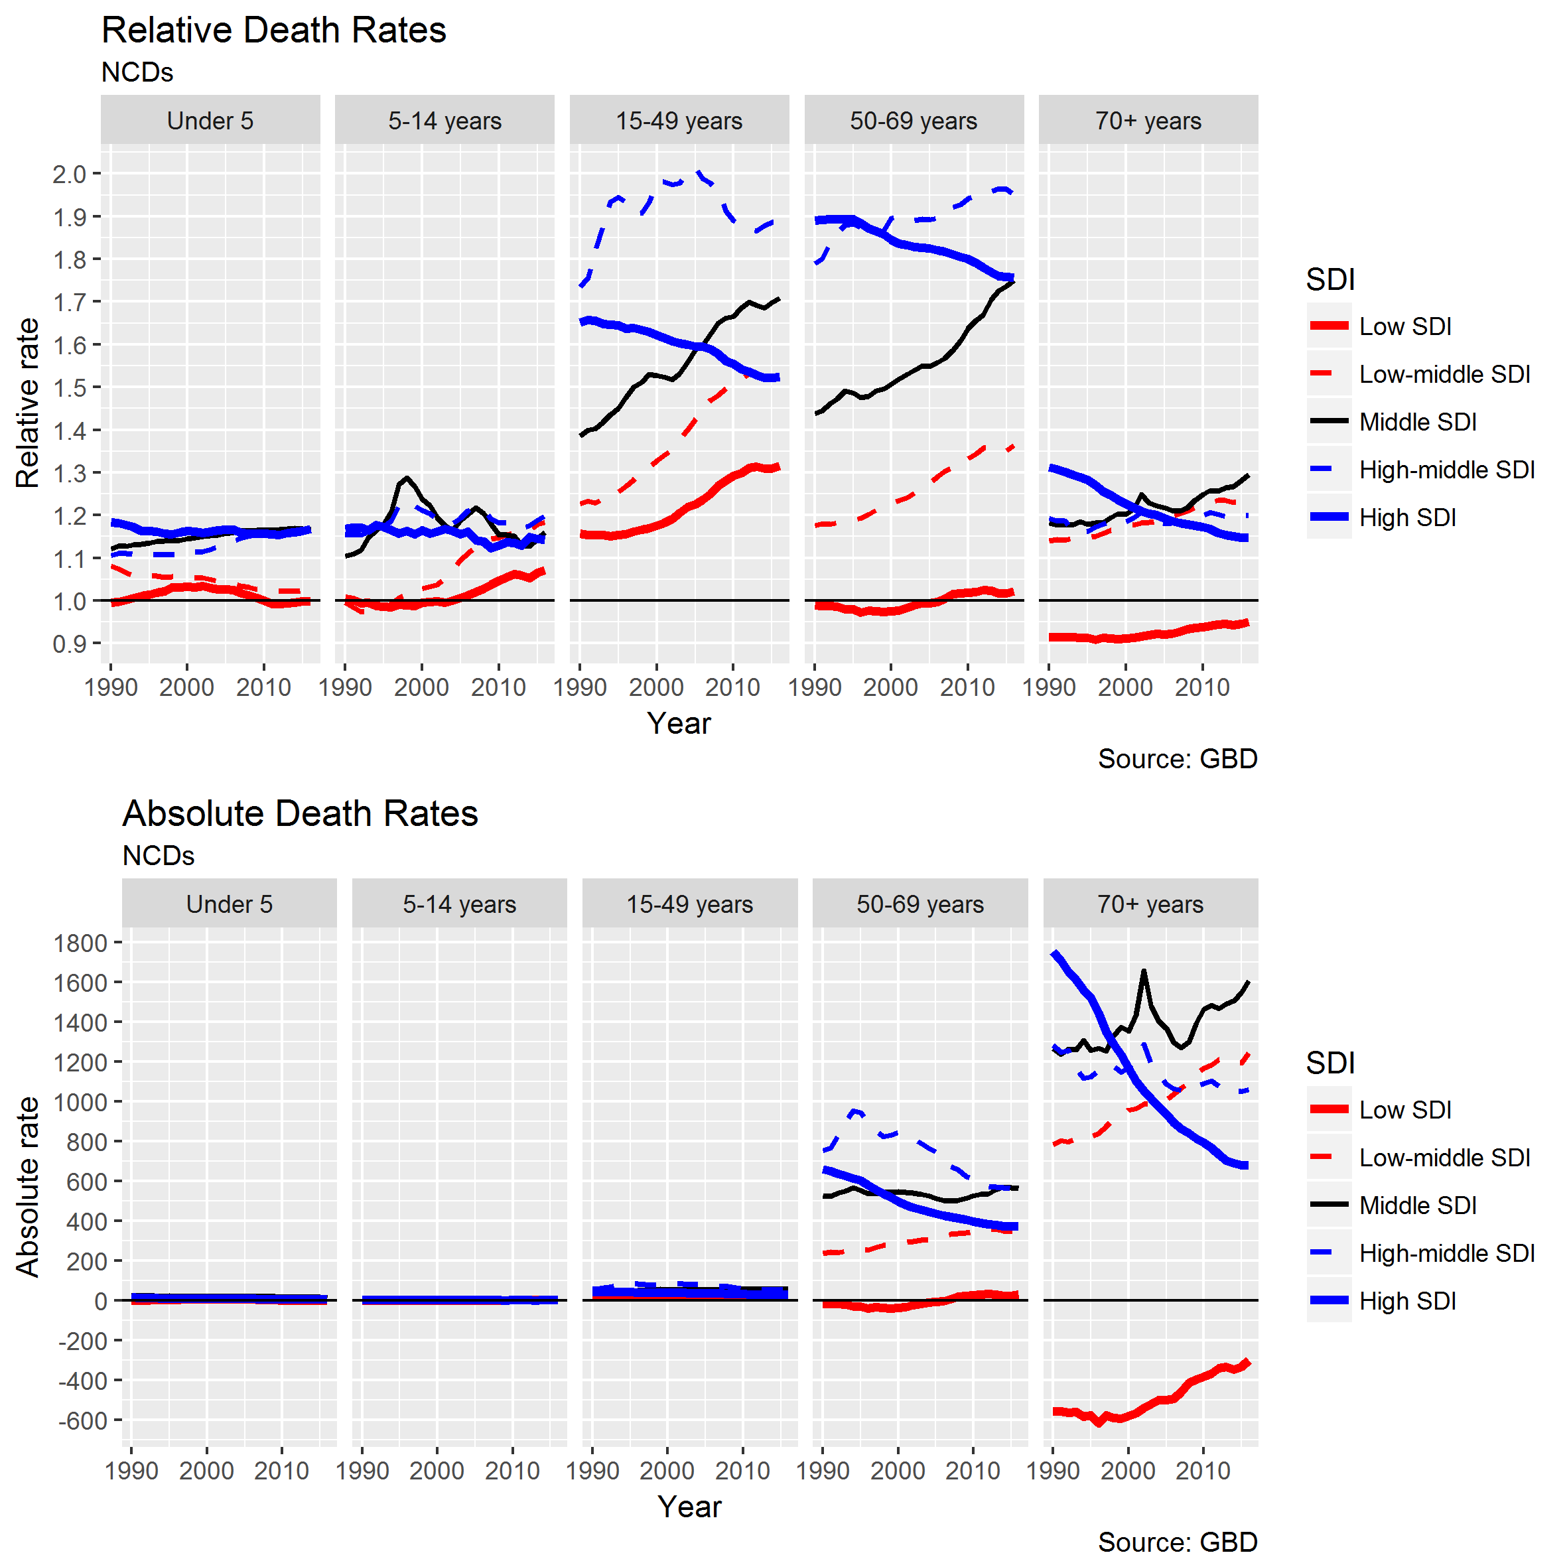

Figure 7 Relative (Male / Female) and absolute (Male - Female) death rates by age group and SDI, for NCDs only

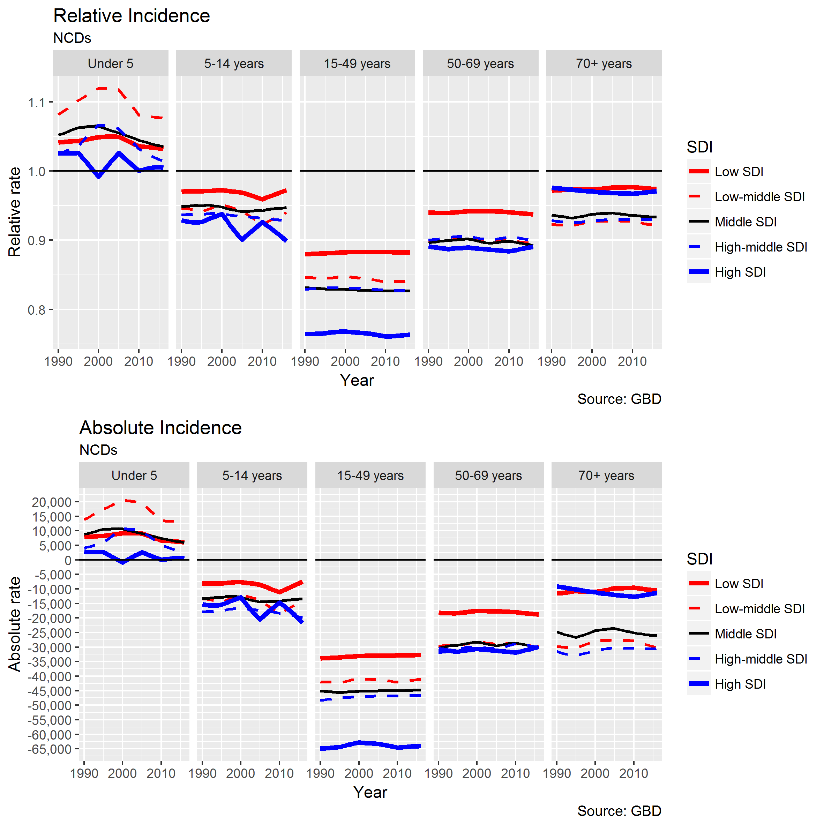

Figure 8 Relative (Male / Female) and Absolute (Male - Female) incidence of NCDs by age group and SDI, NCDs only

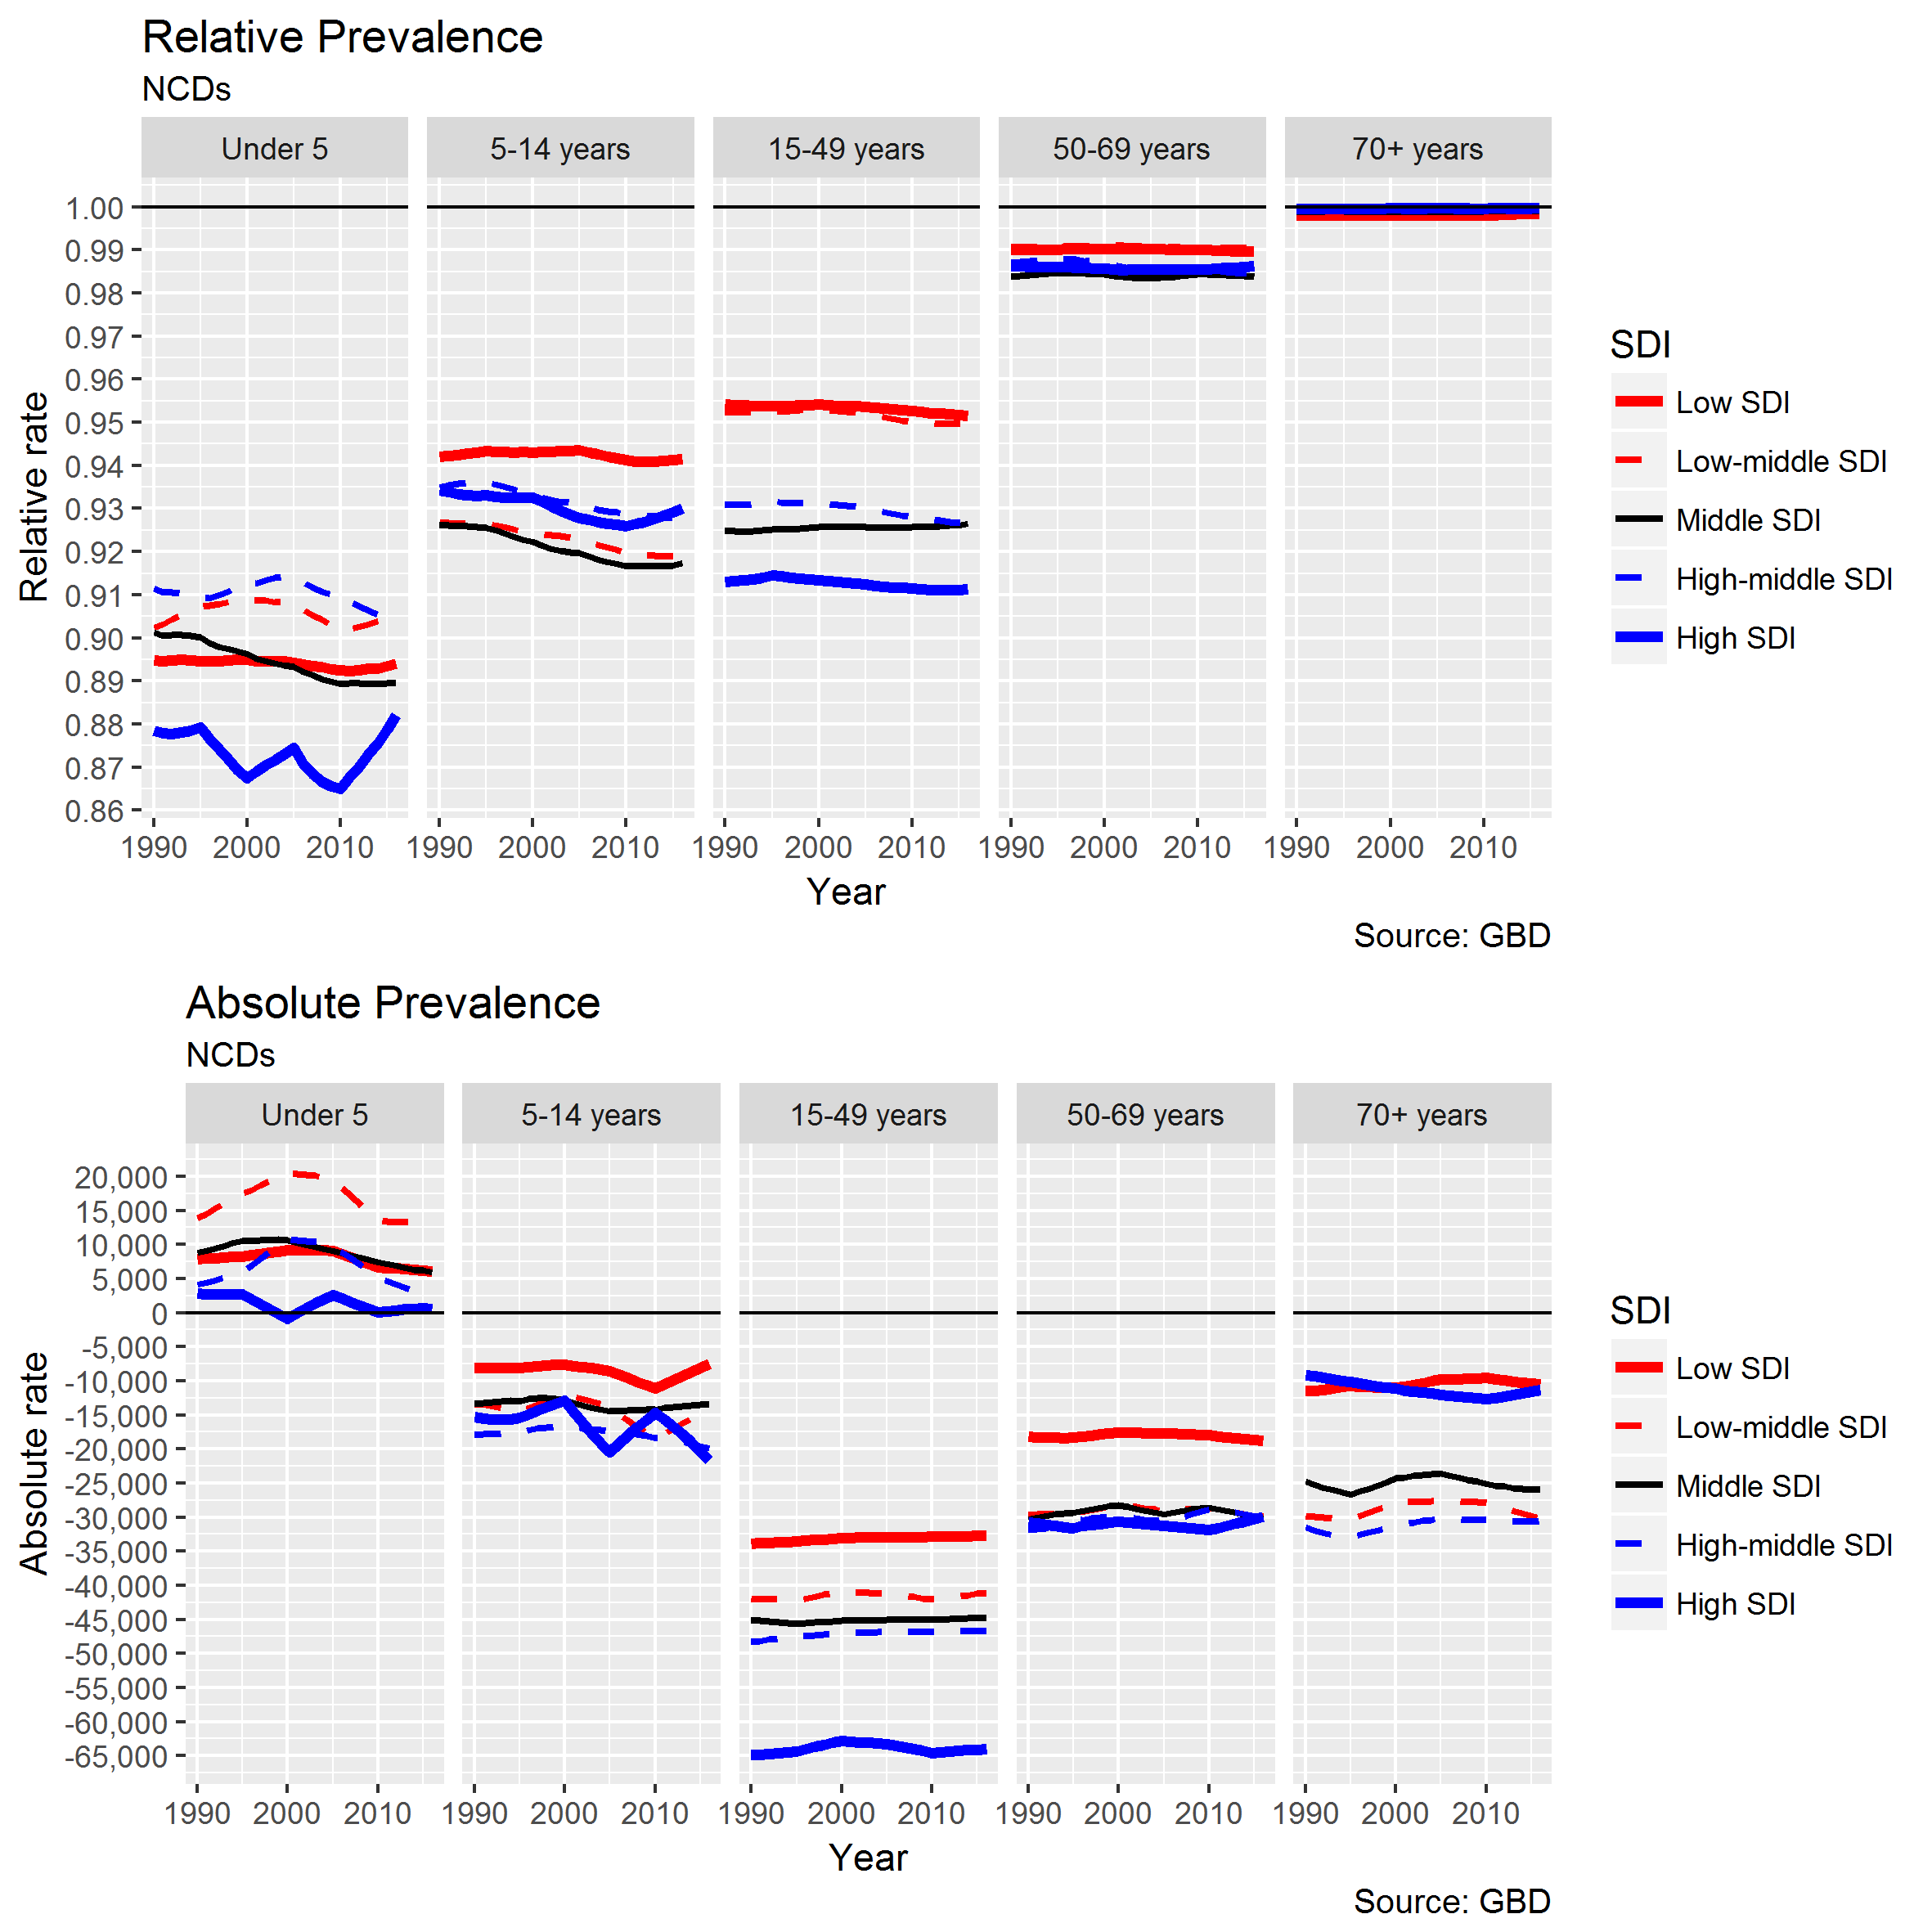

Figure 9 Relative (Male / Female) and Absolute (Male - Female) Prevalence of NCDs by age group and SDI, NCDs only

NOTE: TO INVESTIGATE PATTERN COMPARING ABSOLUTE VS RELATIVE FOR UNDER 5s (With age-group differences? Higher male incidence in 1st year? Lower in 1-4 years?)

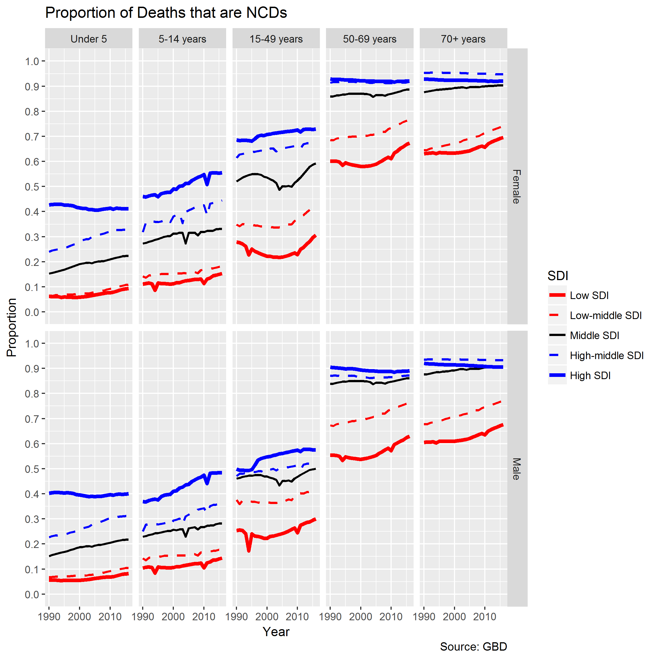

Figure 10 Proportion of all deaths that are due to NCDs. By age group, SDI, and gender

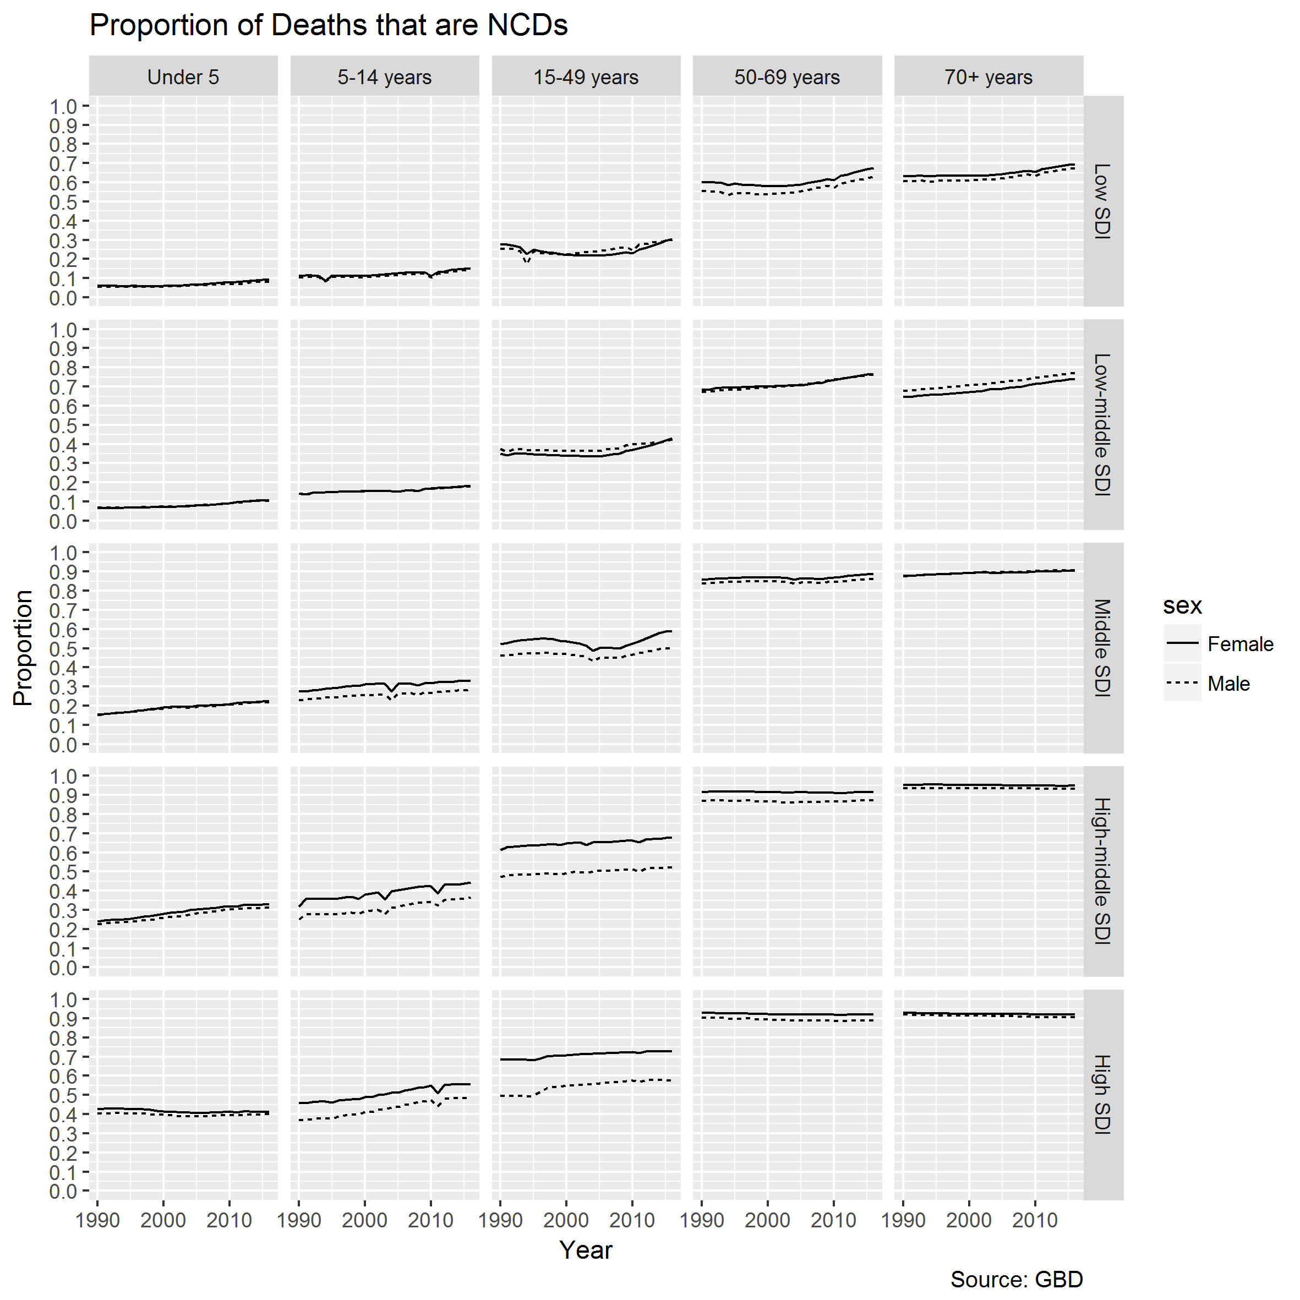

Figure 11 Female (solid line) and male (dashed lines) proportions of deaths that are NCDs, faceted by age group (columns) and SDI status (rows)

Note changing order (male cf female) with increased SDI in, especially, early adulthood and middle age.

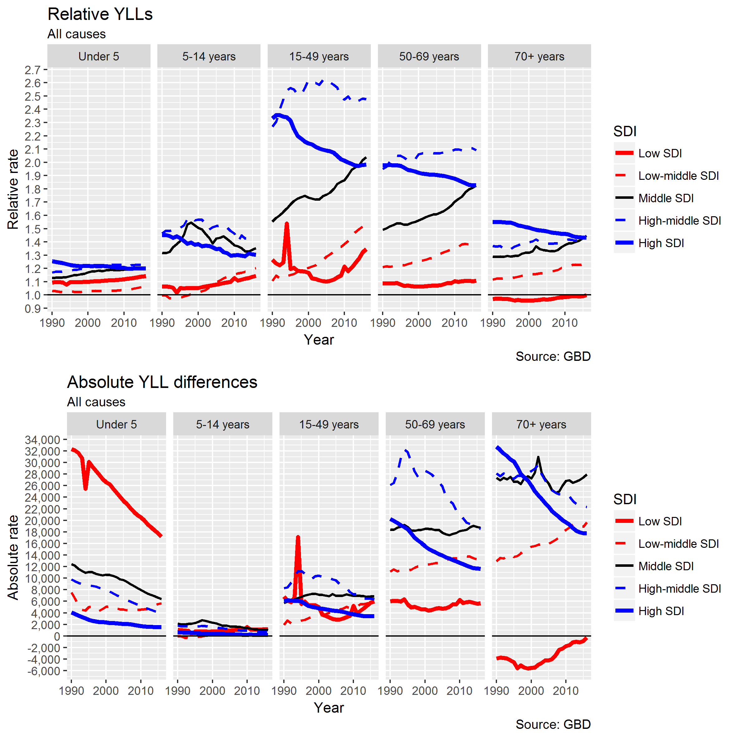

Figure 12 Relative (Male / Female) and absolute (Male - Female) differences in Years of Life Lost (YLLs) by age group and SDI, due to all causes

Note scale on absolute rates cf next figure (NCDs only)

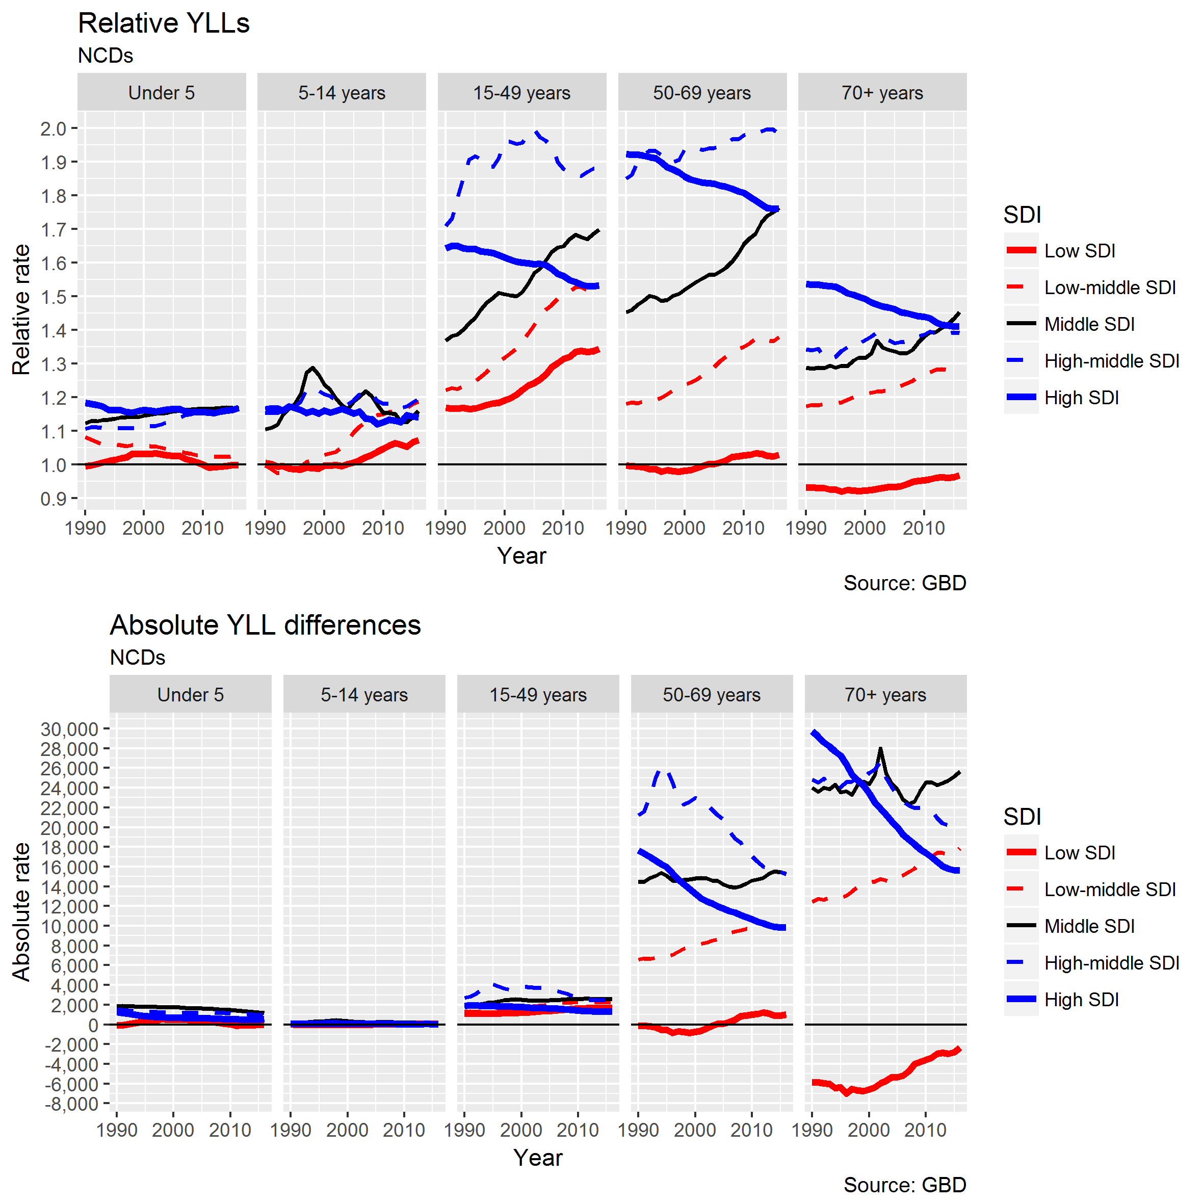

Figure 13 Relative (Male / Female) and absolute (Male - Female) differences in YLLs by age group and SDI, NCDs only

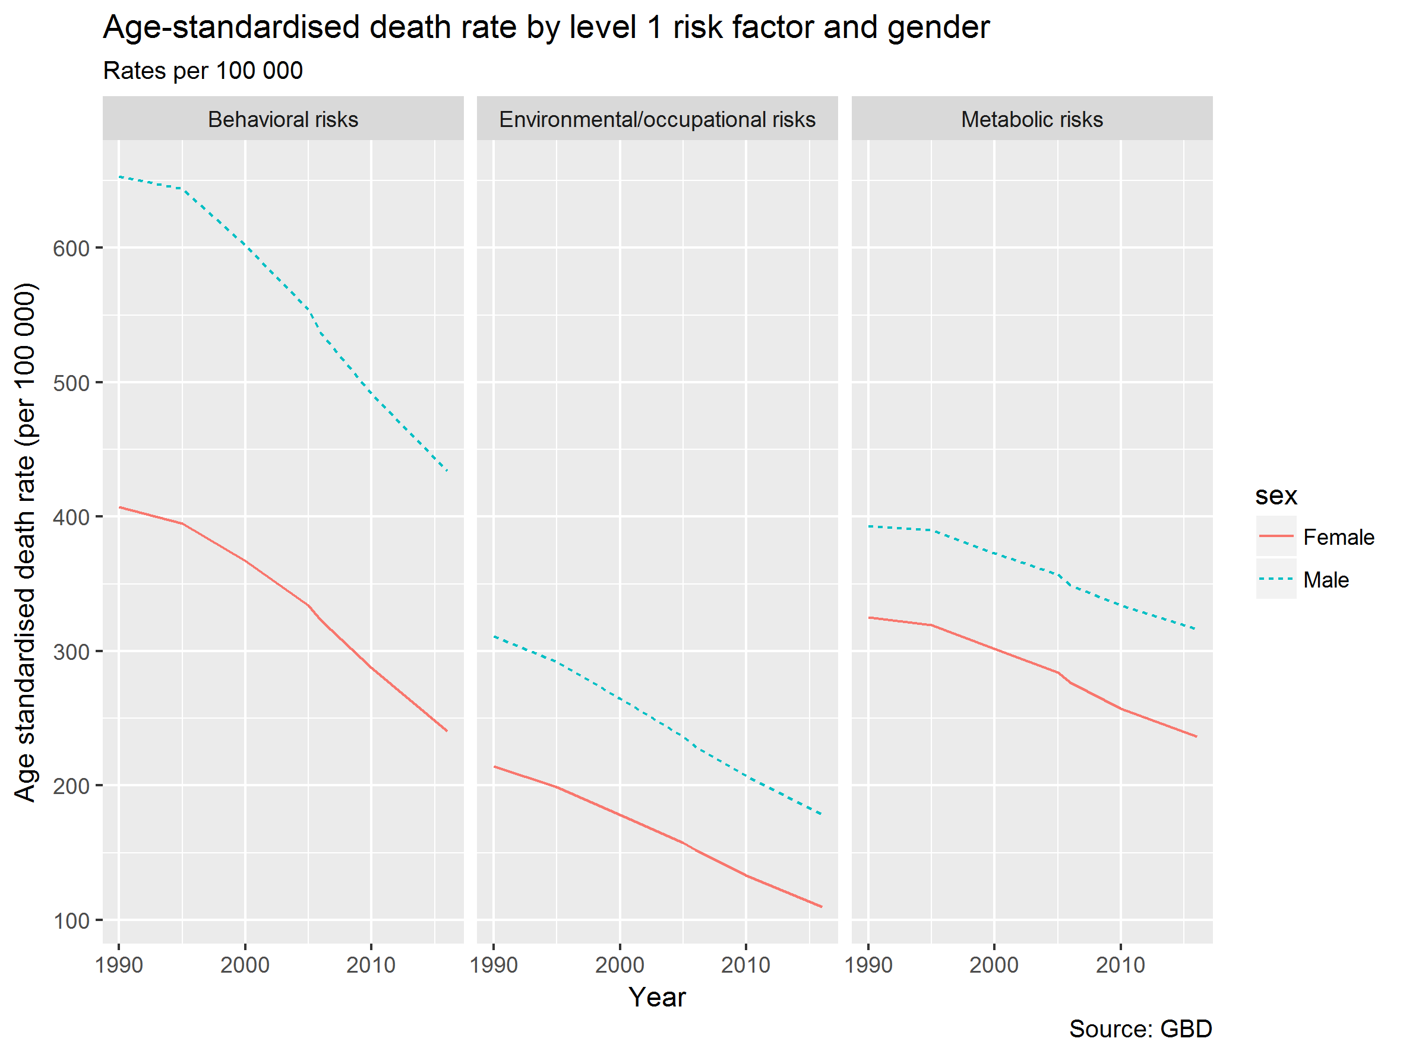

Figure 14 Age-standardised death rates by level 1 risk factor (males and females)

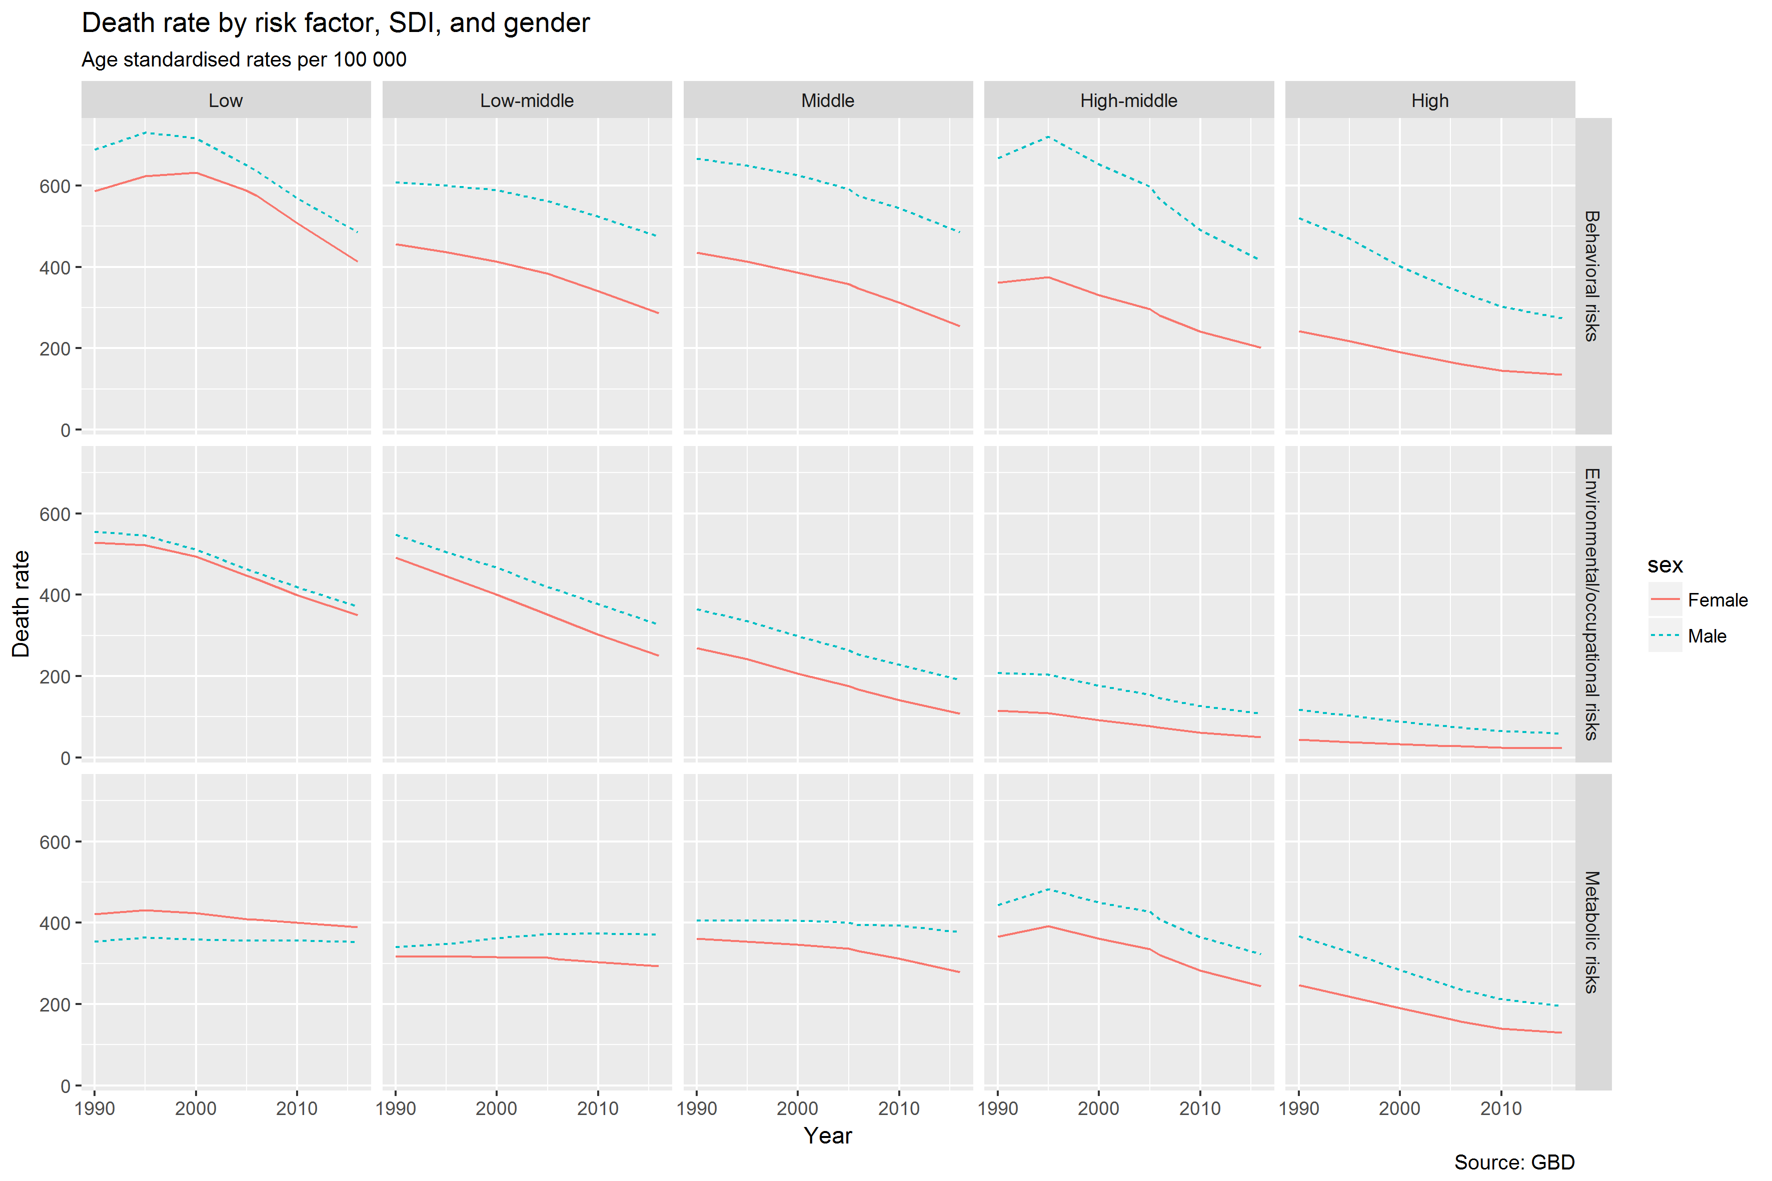

Figure 15 Death rate (all causes) by gender, risk factor, and SDI (Age standardised rates per 100 000)

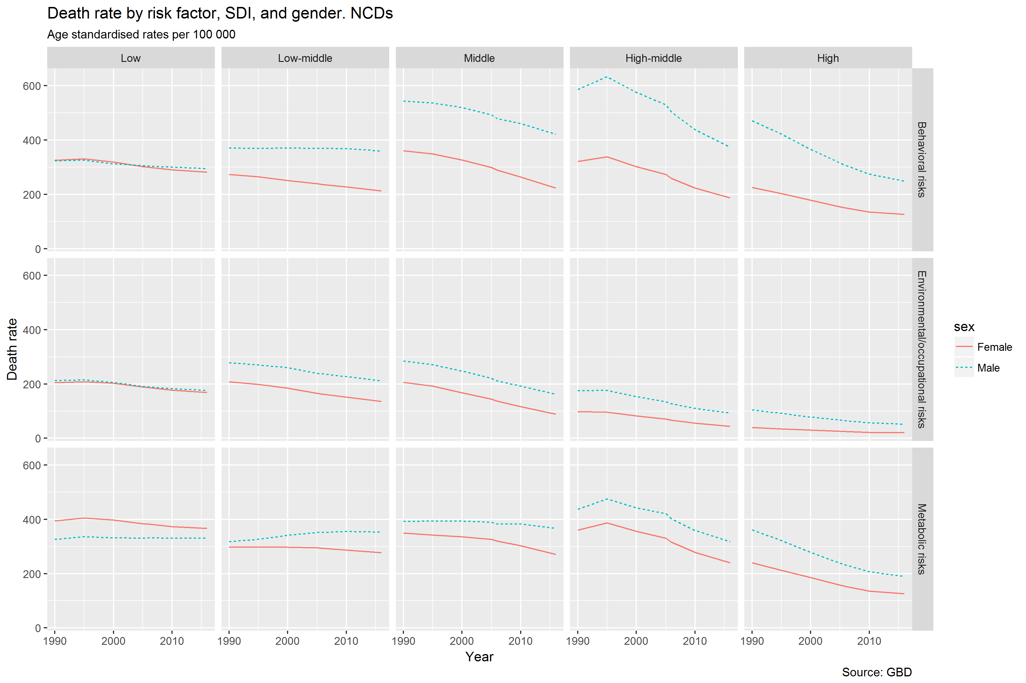

Figure 16 Death rate (NCDs) by gender, risk factor, and SDI (Age standardised rates per 100 000)

(Note: questions about effectiveness of age-standardisation given lower risks shown for low SDI than many higher SDI groups. Younger population? May need to recalculate as index of average age-specific rates since 1990 or similar.)

Note the differences are negative (higher female than male) in low SDI for behavioural risks and occupation risks. For this reason proportionate breakdowns of contributors to male excess are not appropriate, but absolute differences (adding and subtracting different contributory factors) are.

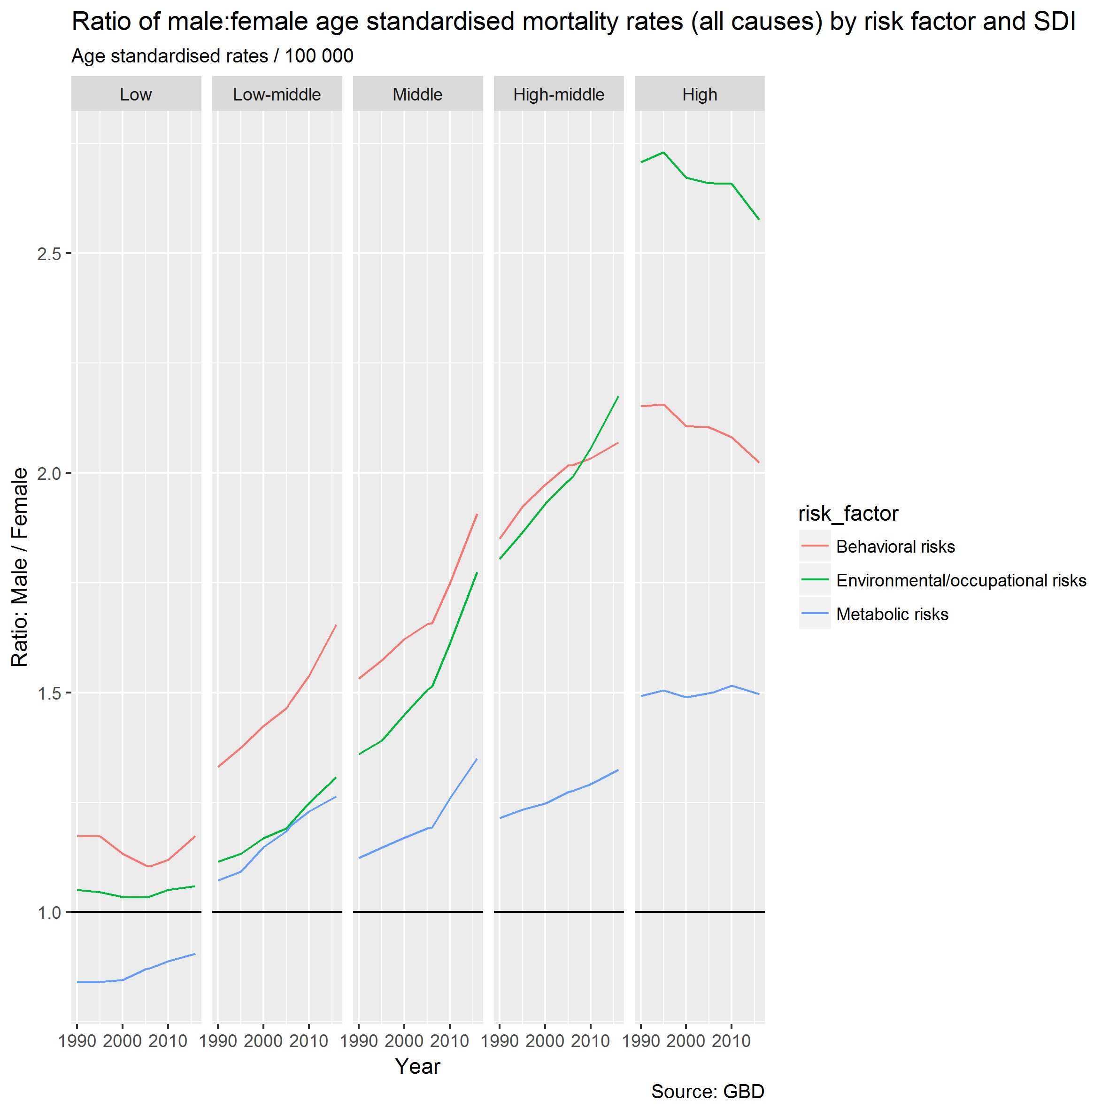

Figure 17 Relative rates (Male/Female) in age standardised all-cause mortality rates by SDI and level 1 risk factor

Upwards trends in middle/high-middle SDI in *relative* differences for all cause. Now let’s look at this for NCDs only.

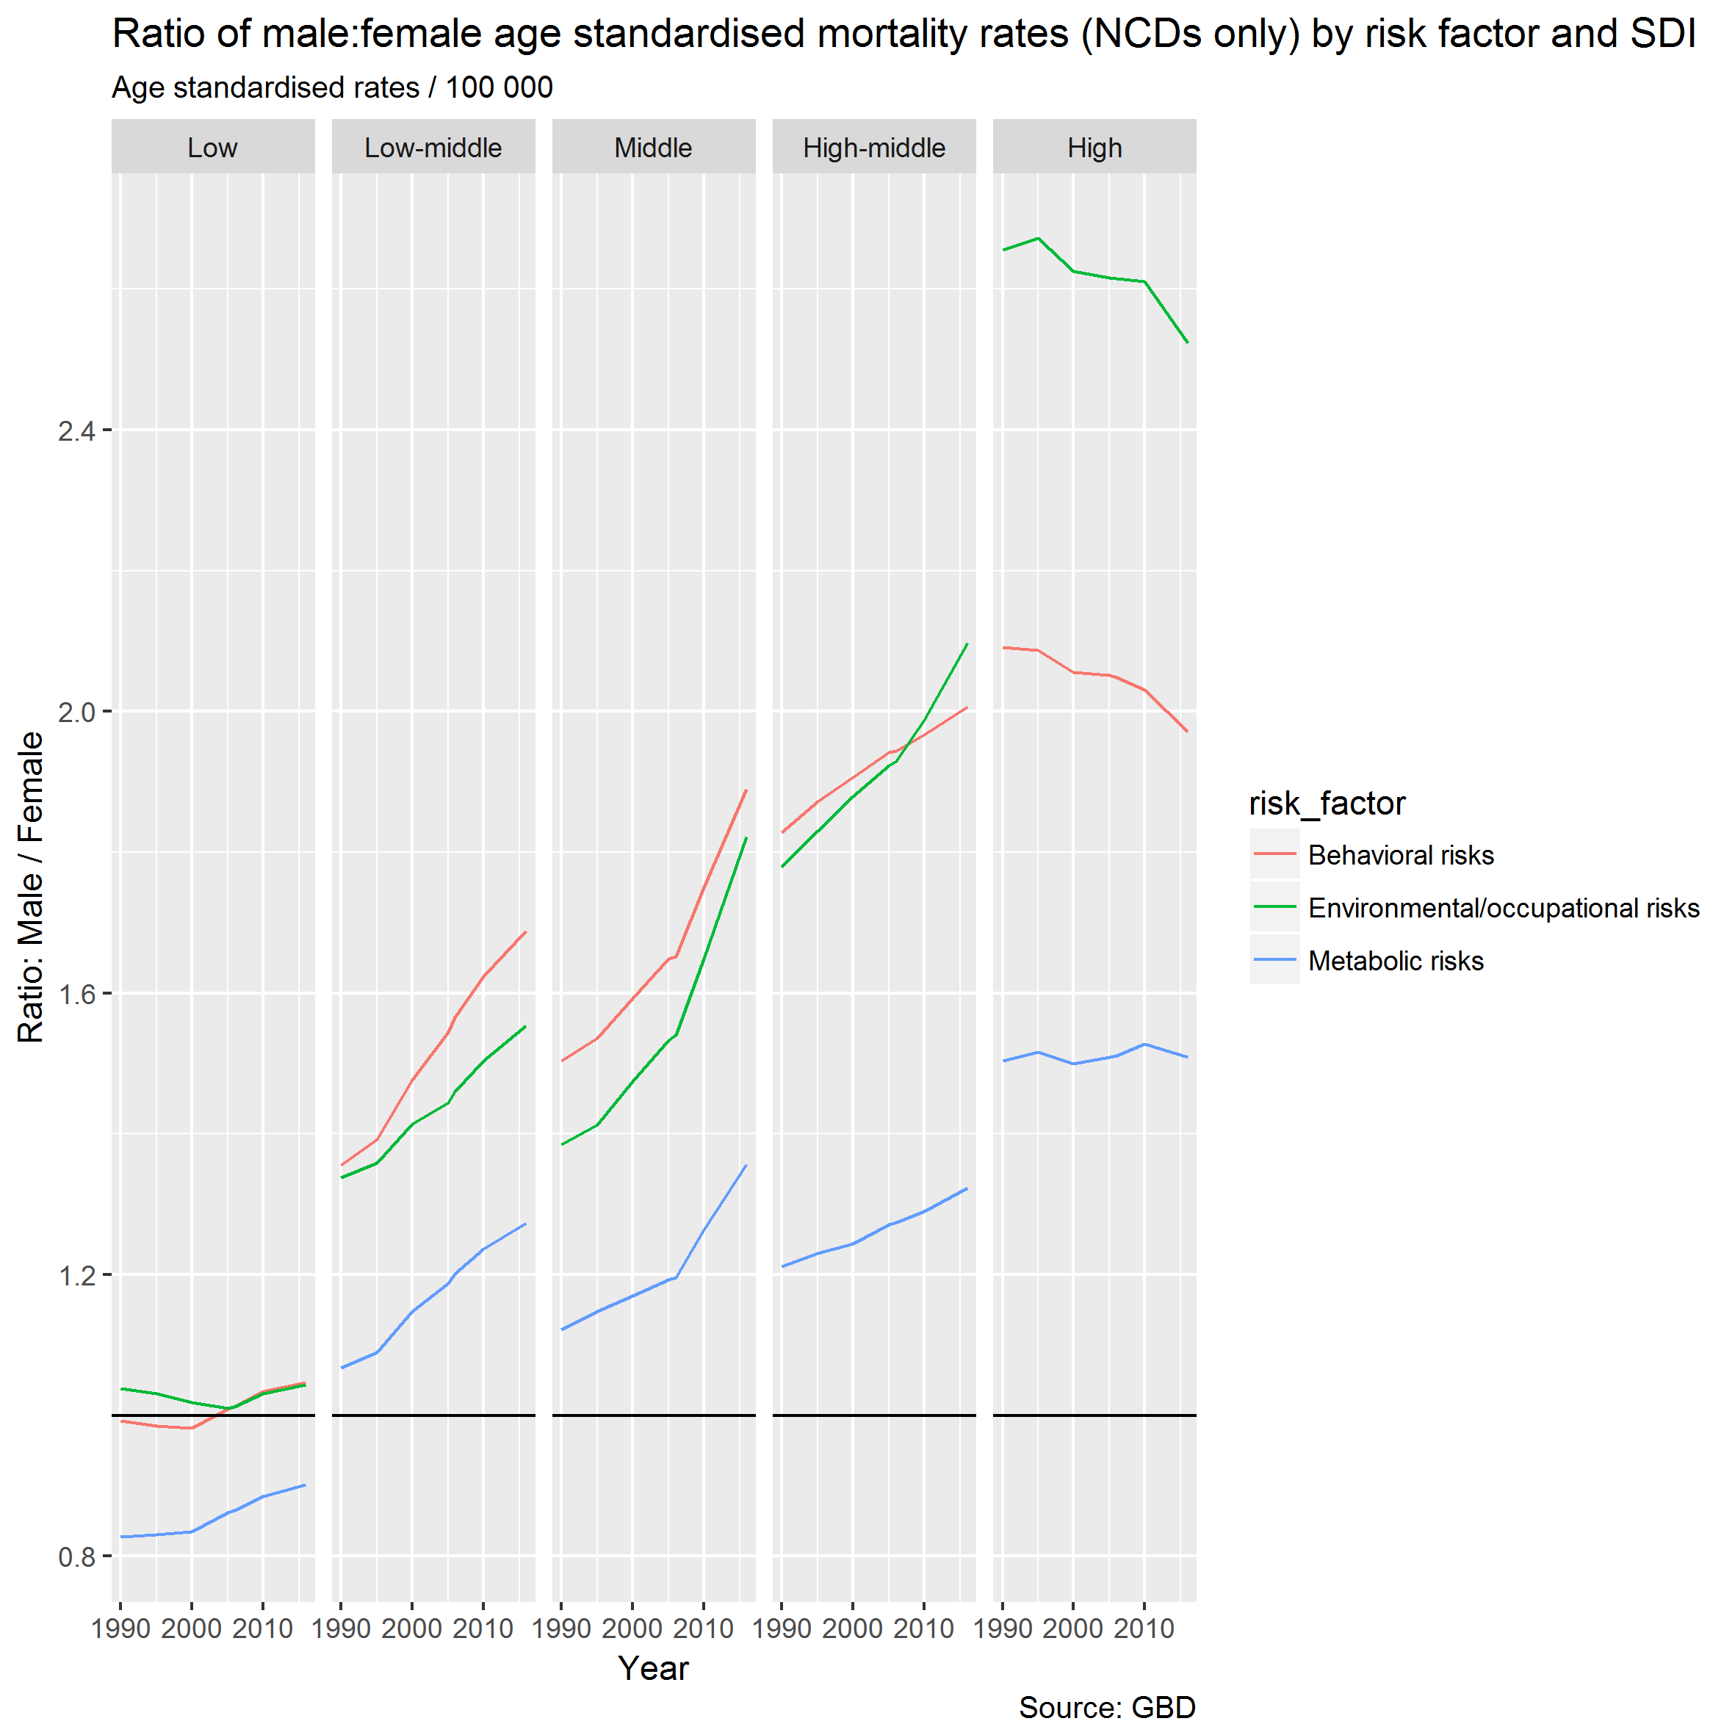

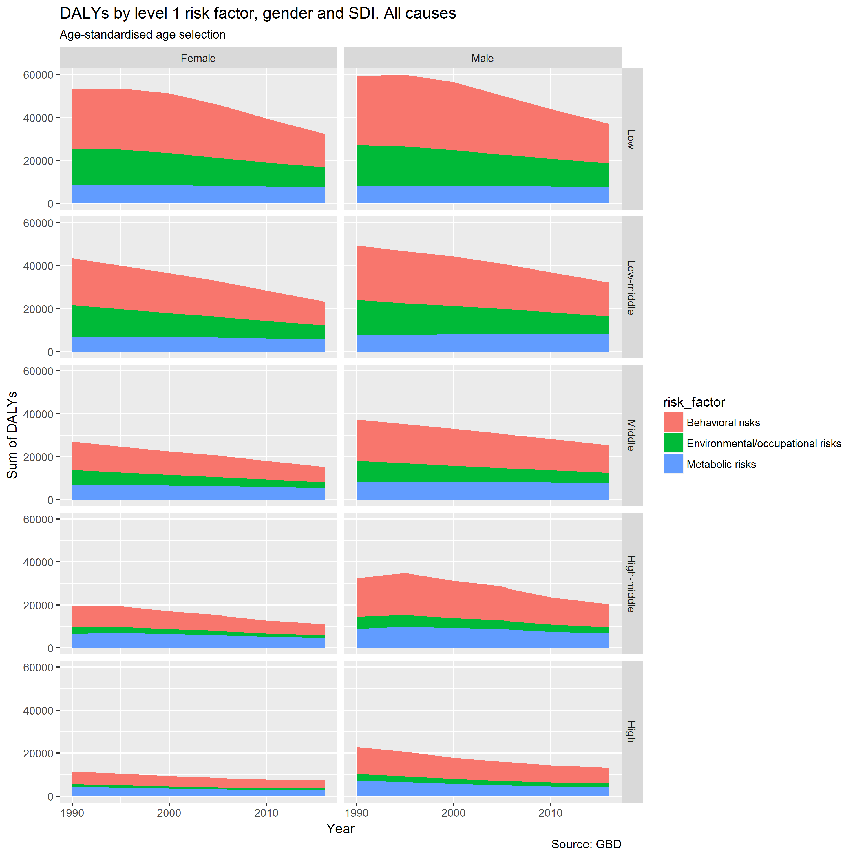

Figure 18 Sum of DALYs (age-standardised age selection) by level 1 risk factor, SDI, and gender. All causes

Now let’s look at the proportion of DALYs by level 1 risk factor

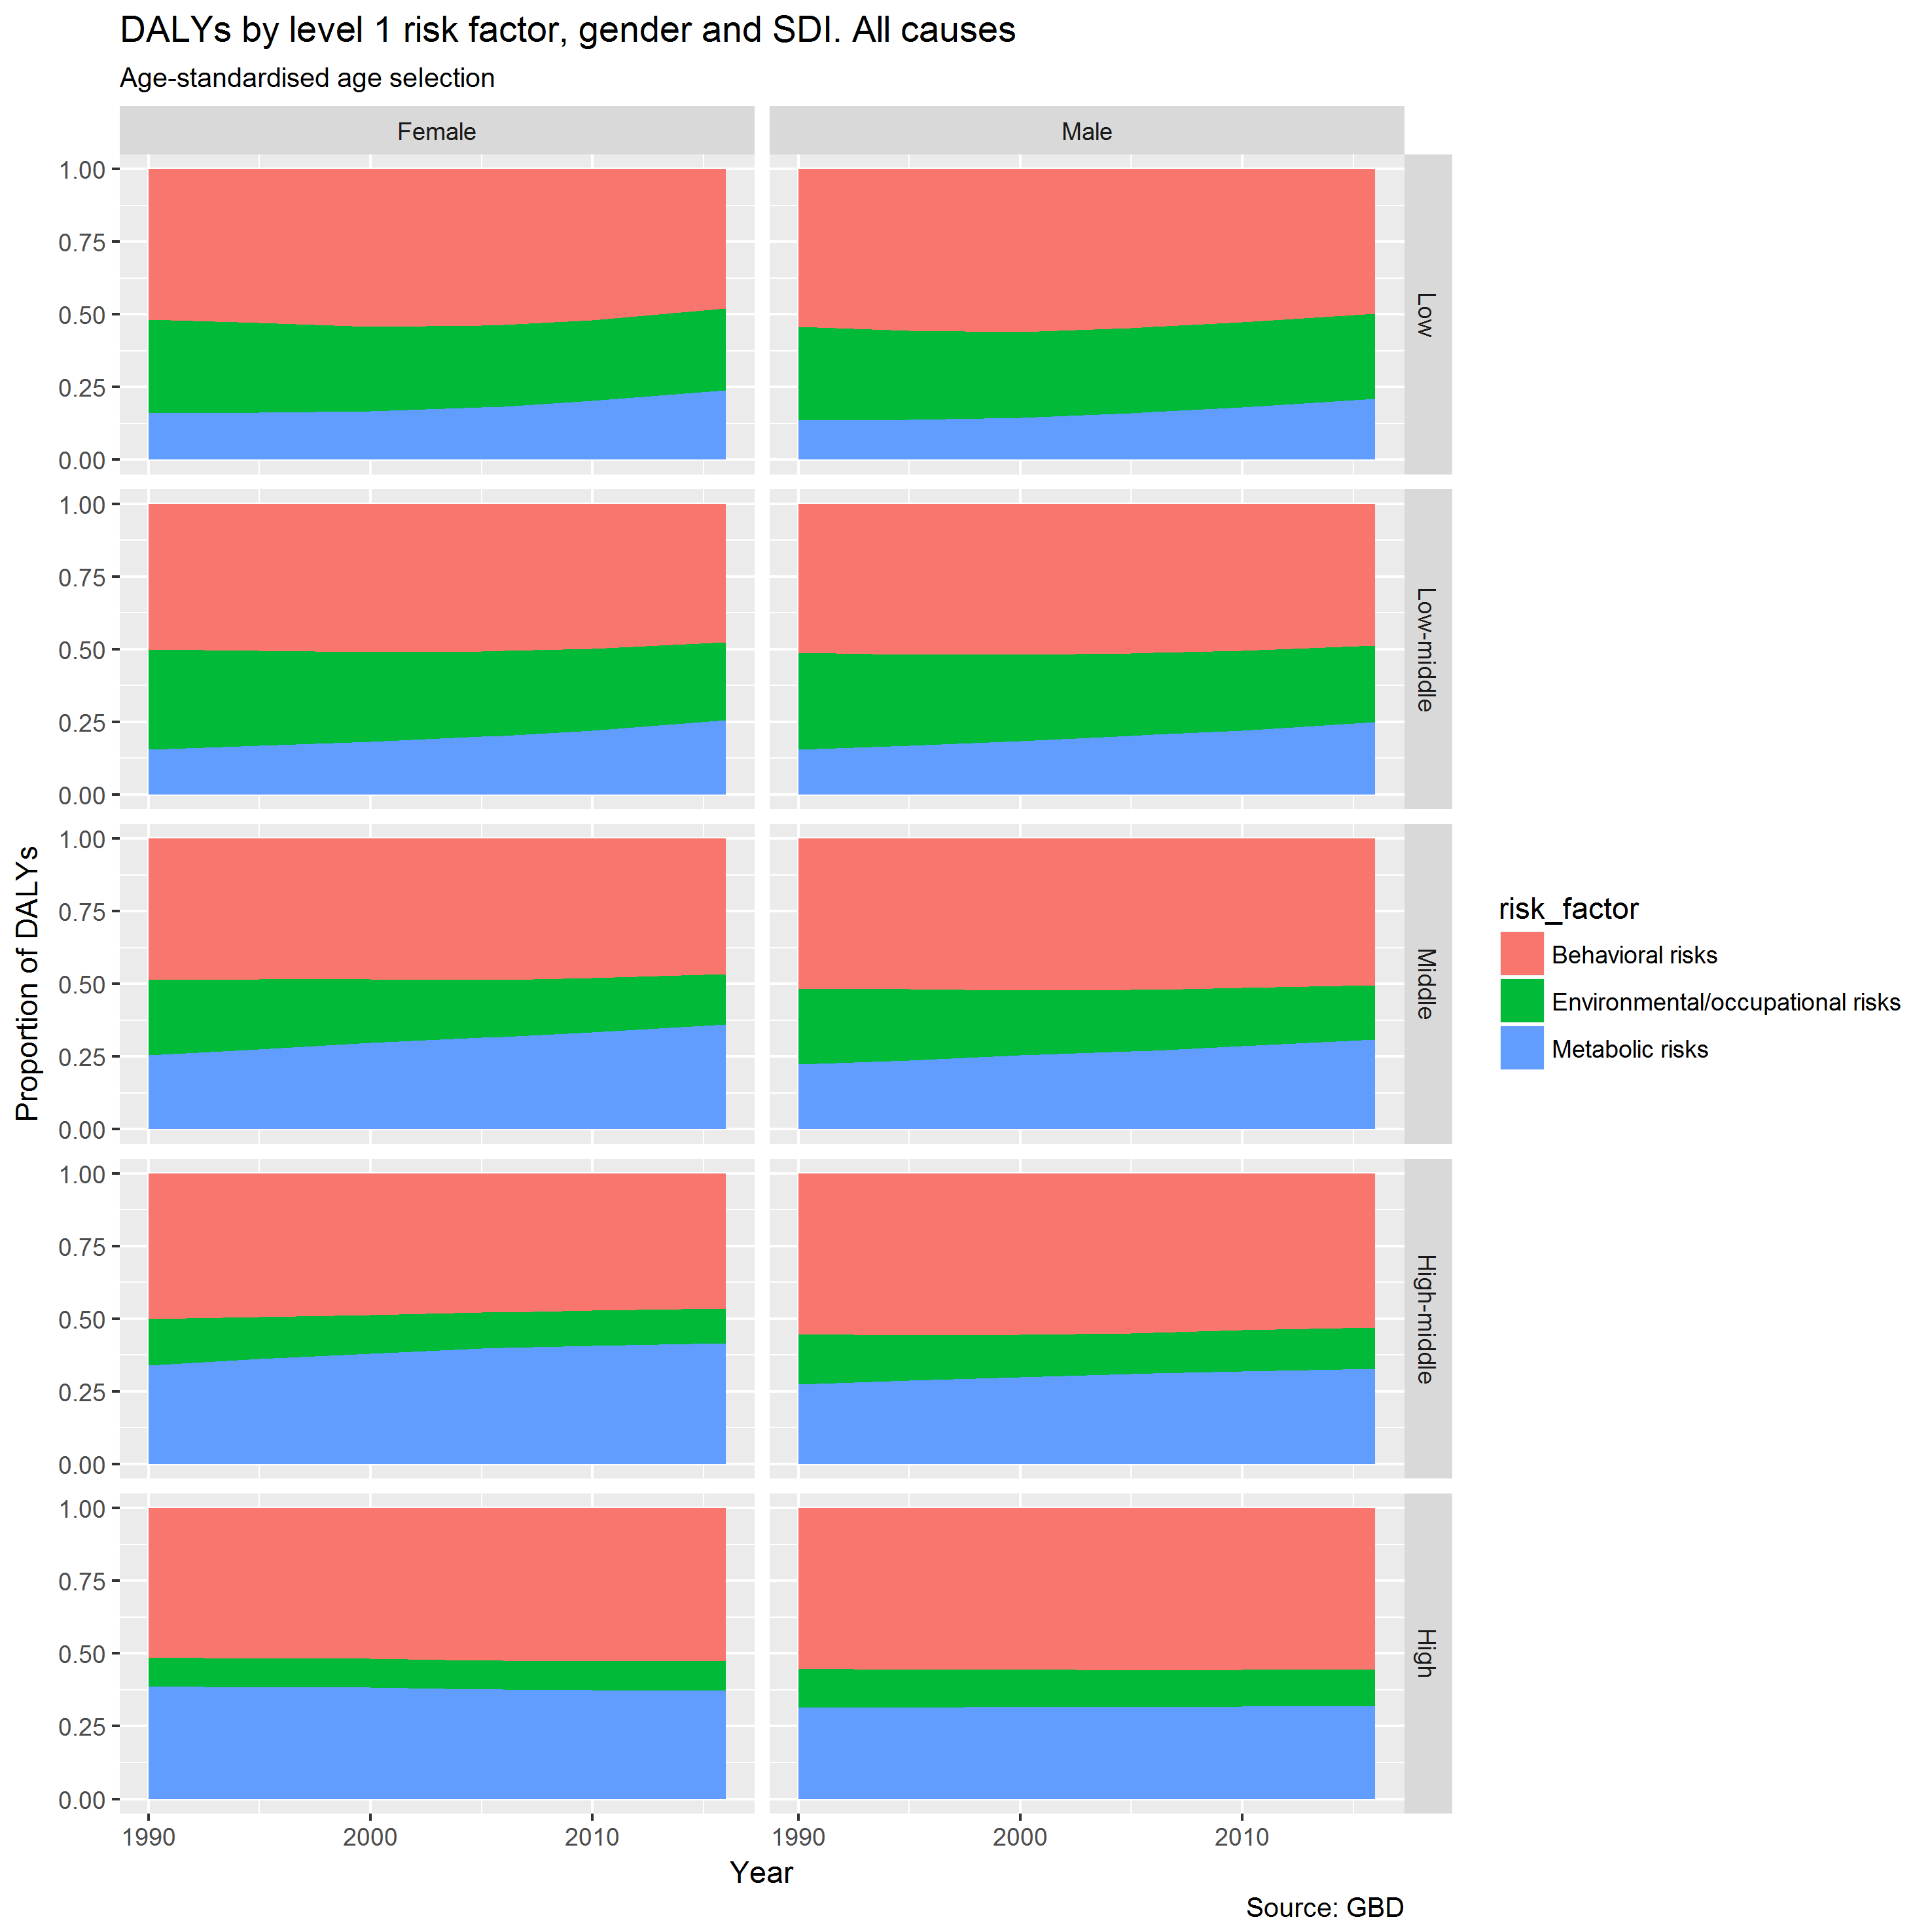

Figure 19 Proportion of DALYs (age-standardised age selection) by level 1 risk factor, SDI, and gender. All causes

The relative proportion by level 1 risk factor has largely stayed similar over time.

Now the above two figures, but for NCDs only.

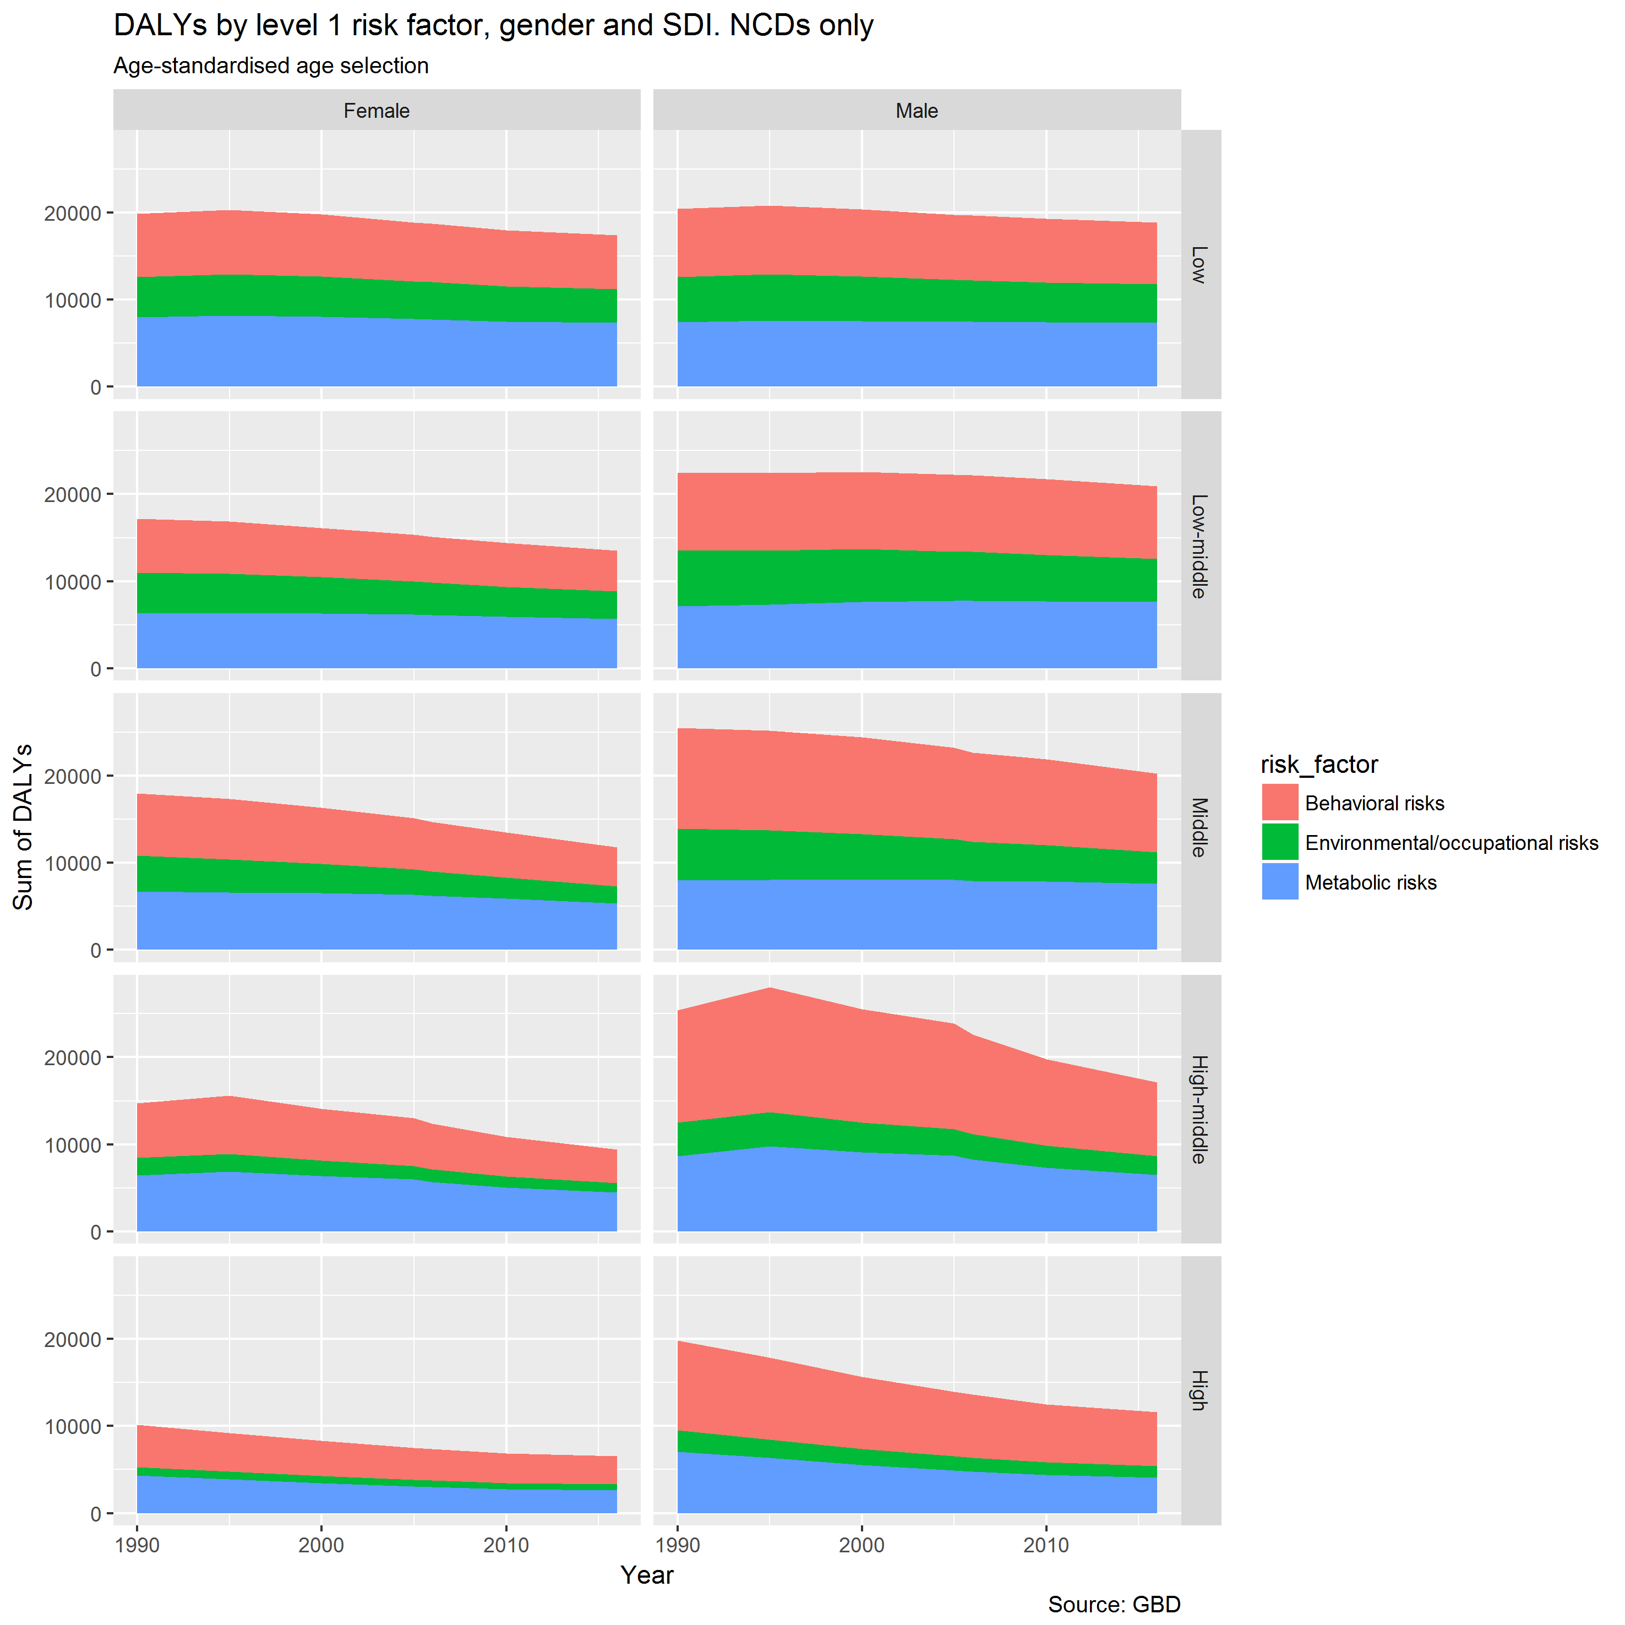

Figure 20 Sum of DALYs (age-standardised age selection) by level 1 risk factor, SDI, and gender. NCDs only

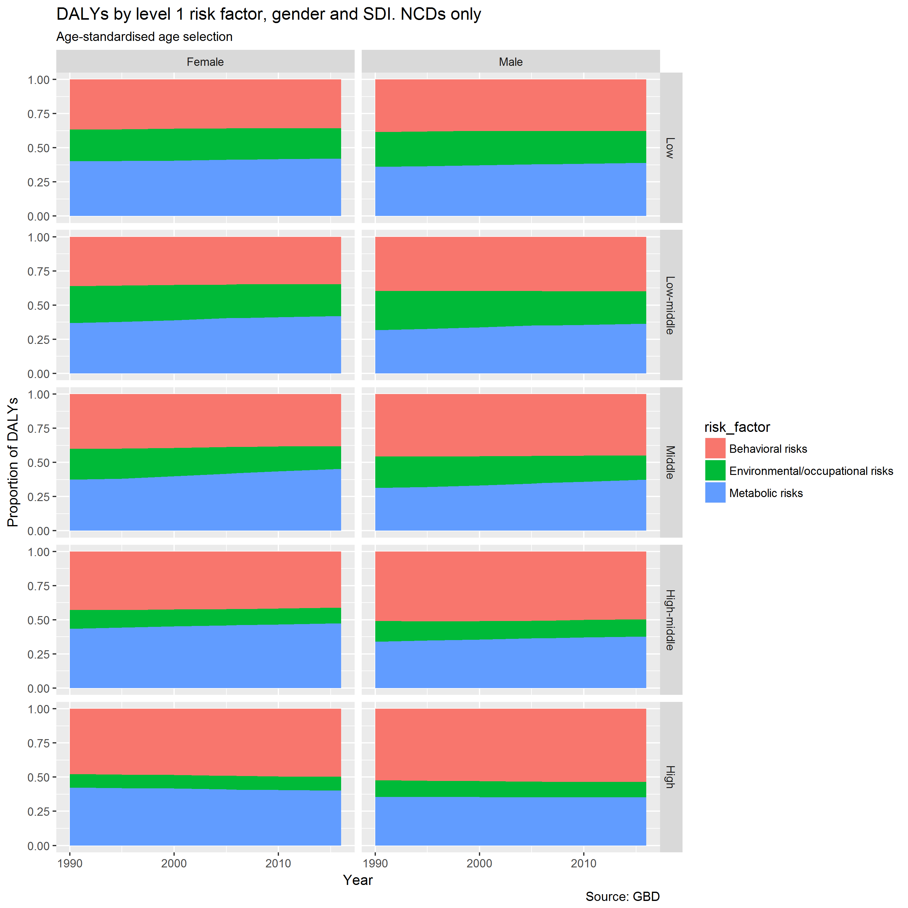

Figure 21 Proportion of DALYs (age-standardised age selection) by level 1 risk factor, SDI, and gender. NCDs only

Perhaps a trend for a reduced proportion of NCDs caused by environmental/occupational risks over time, and more due to metabolic risks.

# Risk Factor Decompositions

For the following figures, start with the bottom risk factor (Black vertical line), then cumulatively add/subtract each risk factor above. The end of the arrow-head shows absolute differences (Male – Female) in age standardised death rates per 100,000 between males and females due to that specific cause. Blue arrows indicate male rates are higher than female rates; red arrows indicate female rates are higher than male rates. The dashed vertical line shows the cumulative effect of each of these risk factors on overall absolute differences in age-standardised mortality.

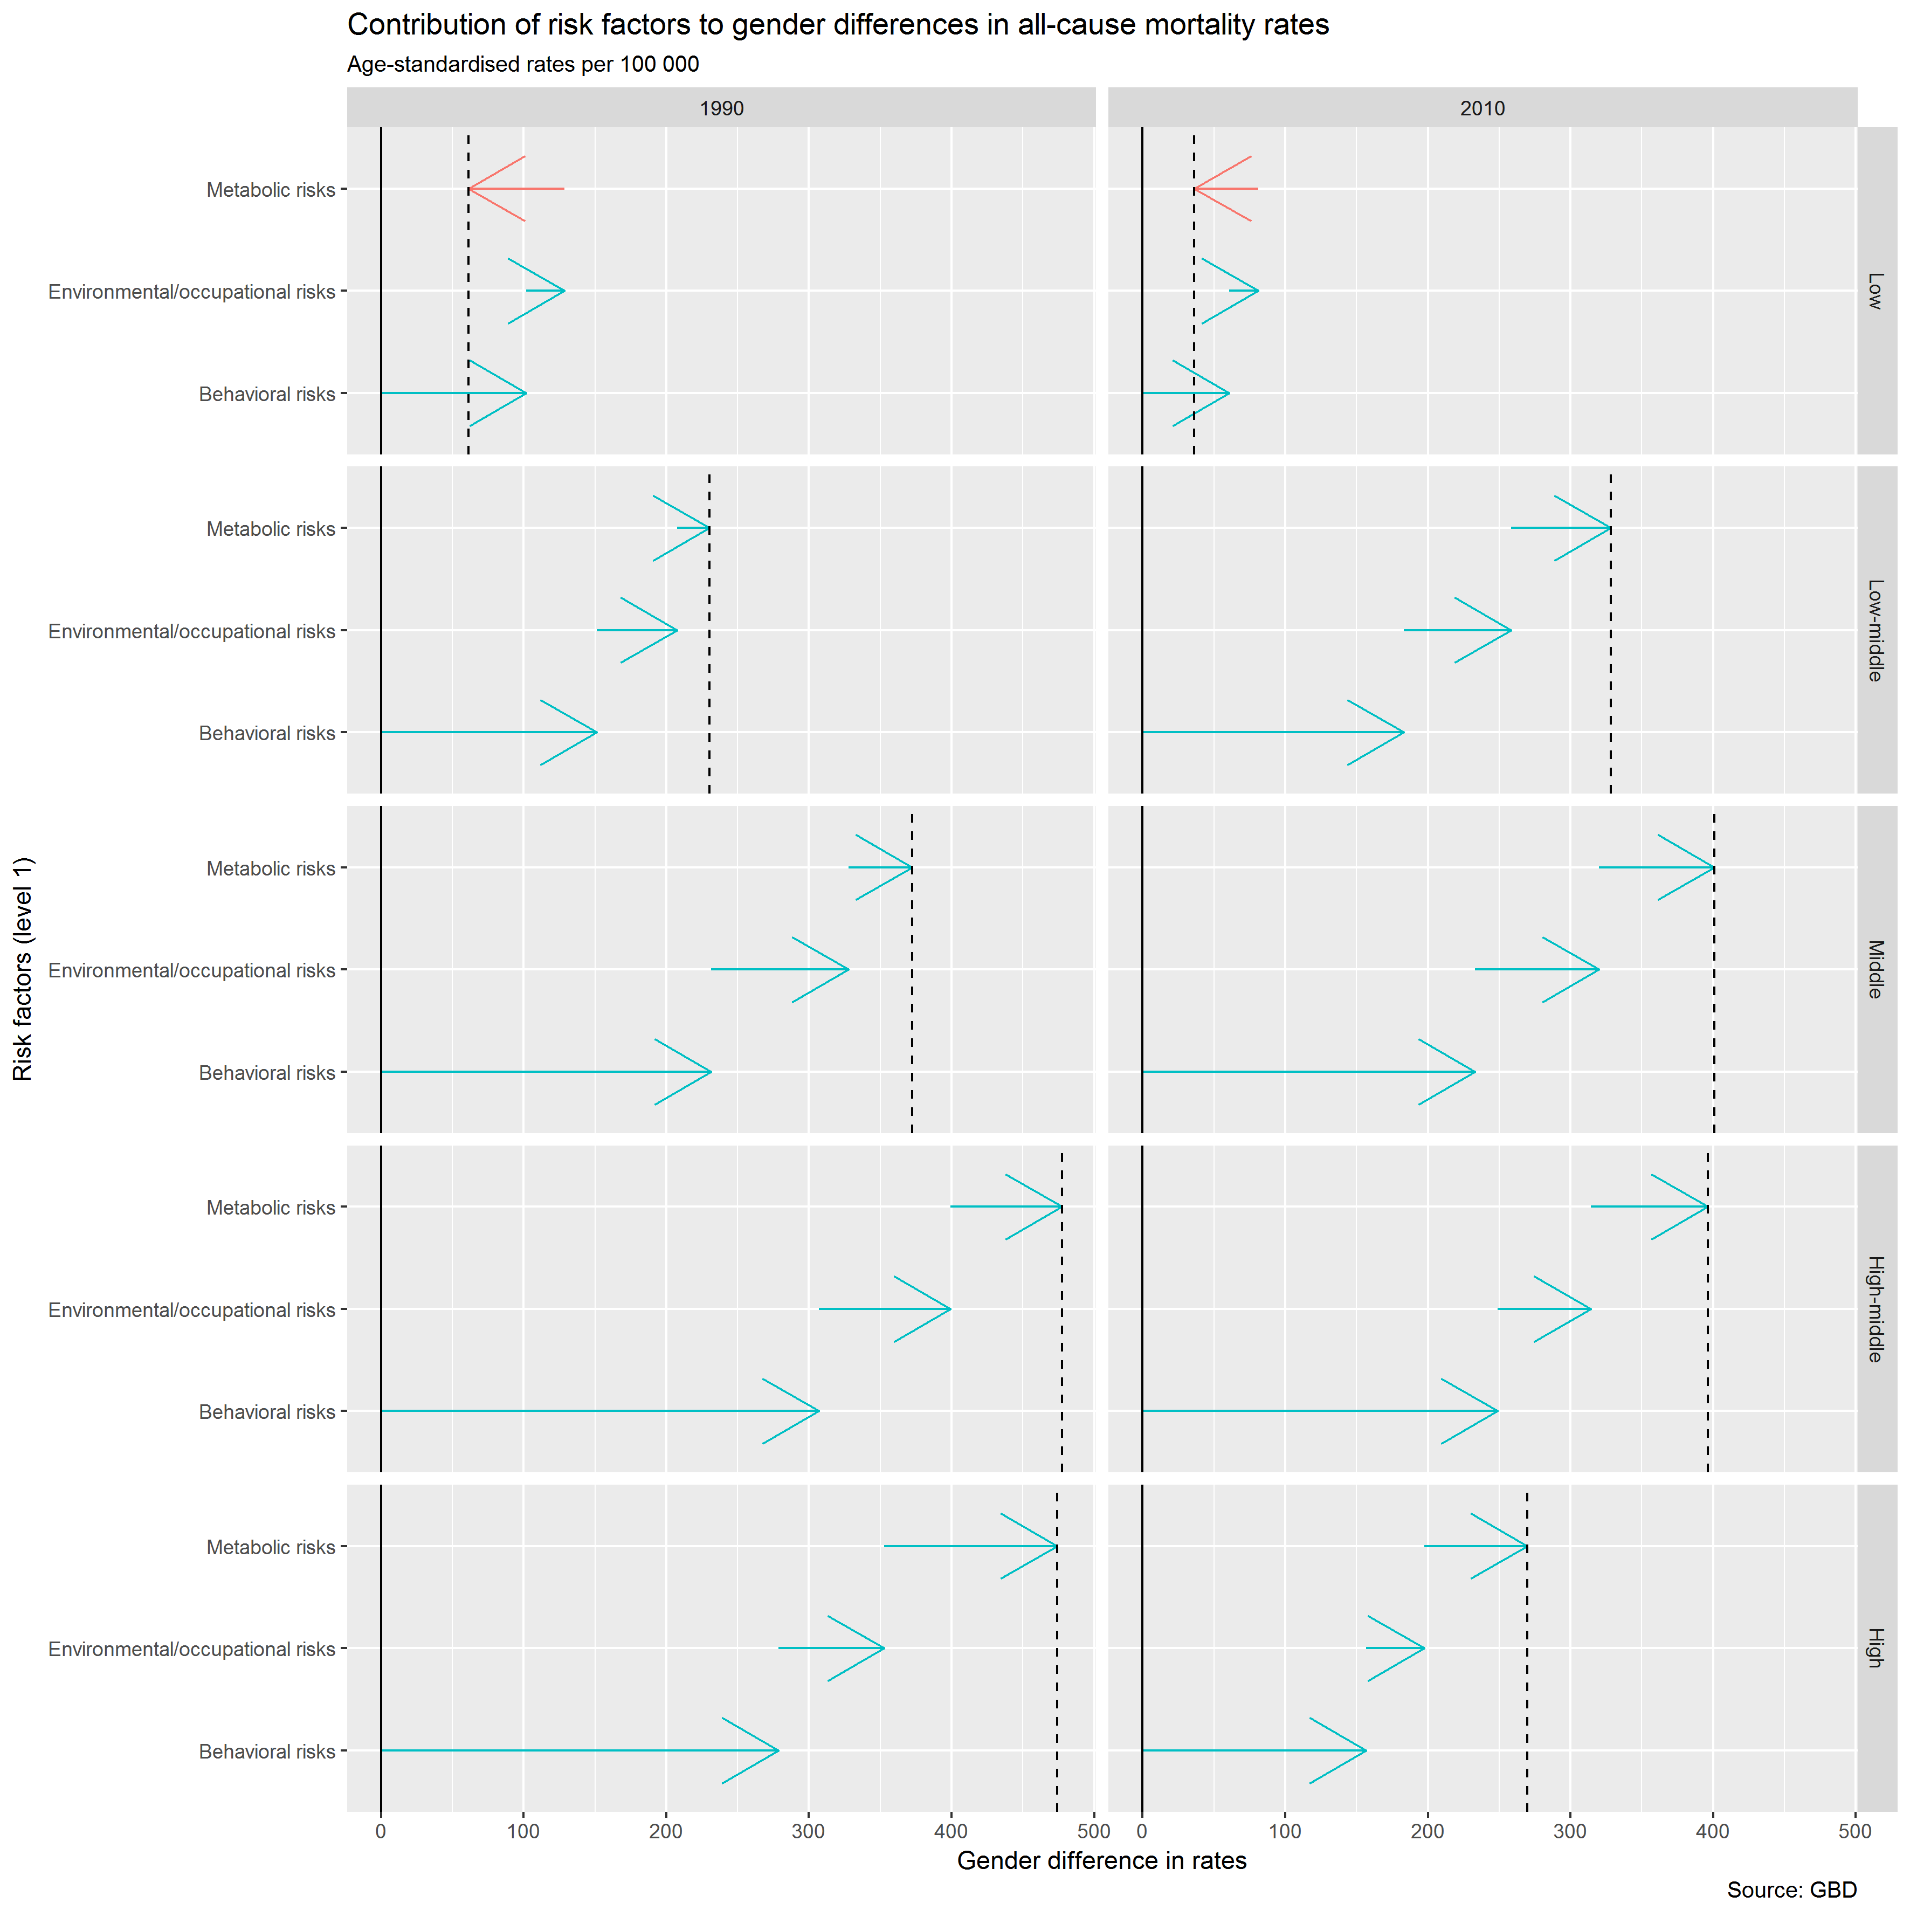

Figure 22 Decomposition of overall gender differences in age-standardised all-cause mortality rates due to level 1 risk factors, by SDI group (lowest at top, highest at bottom), in 1990 and 2010.

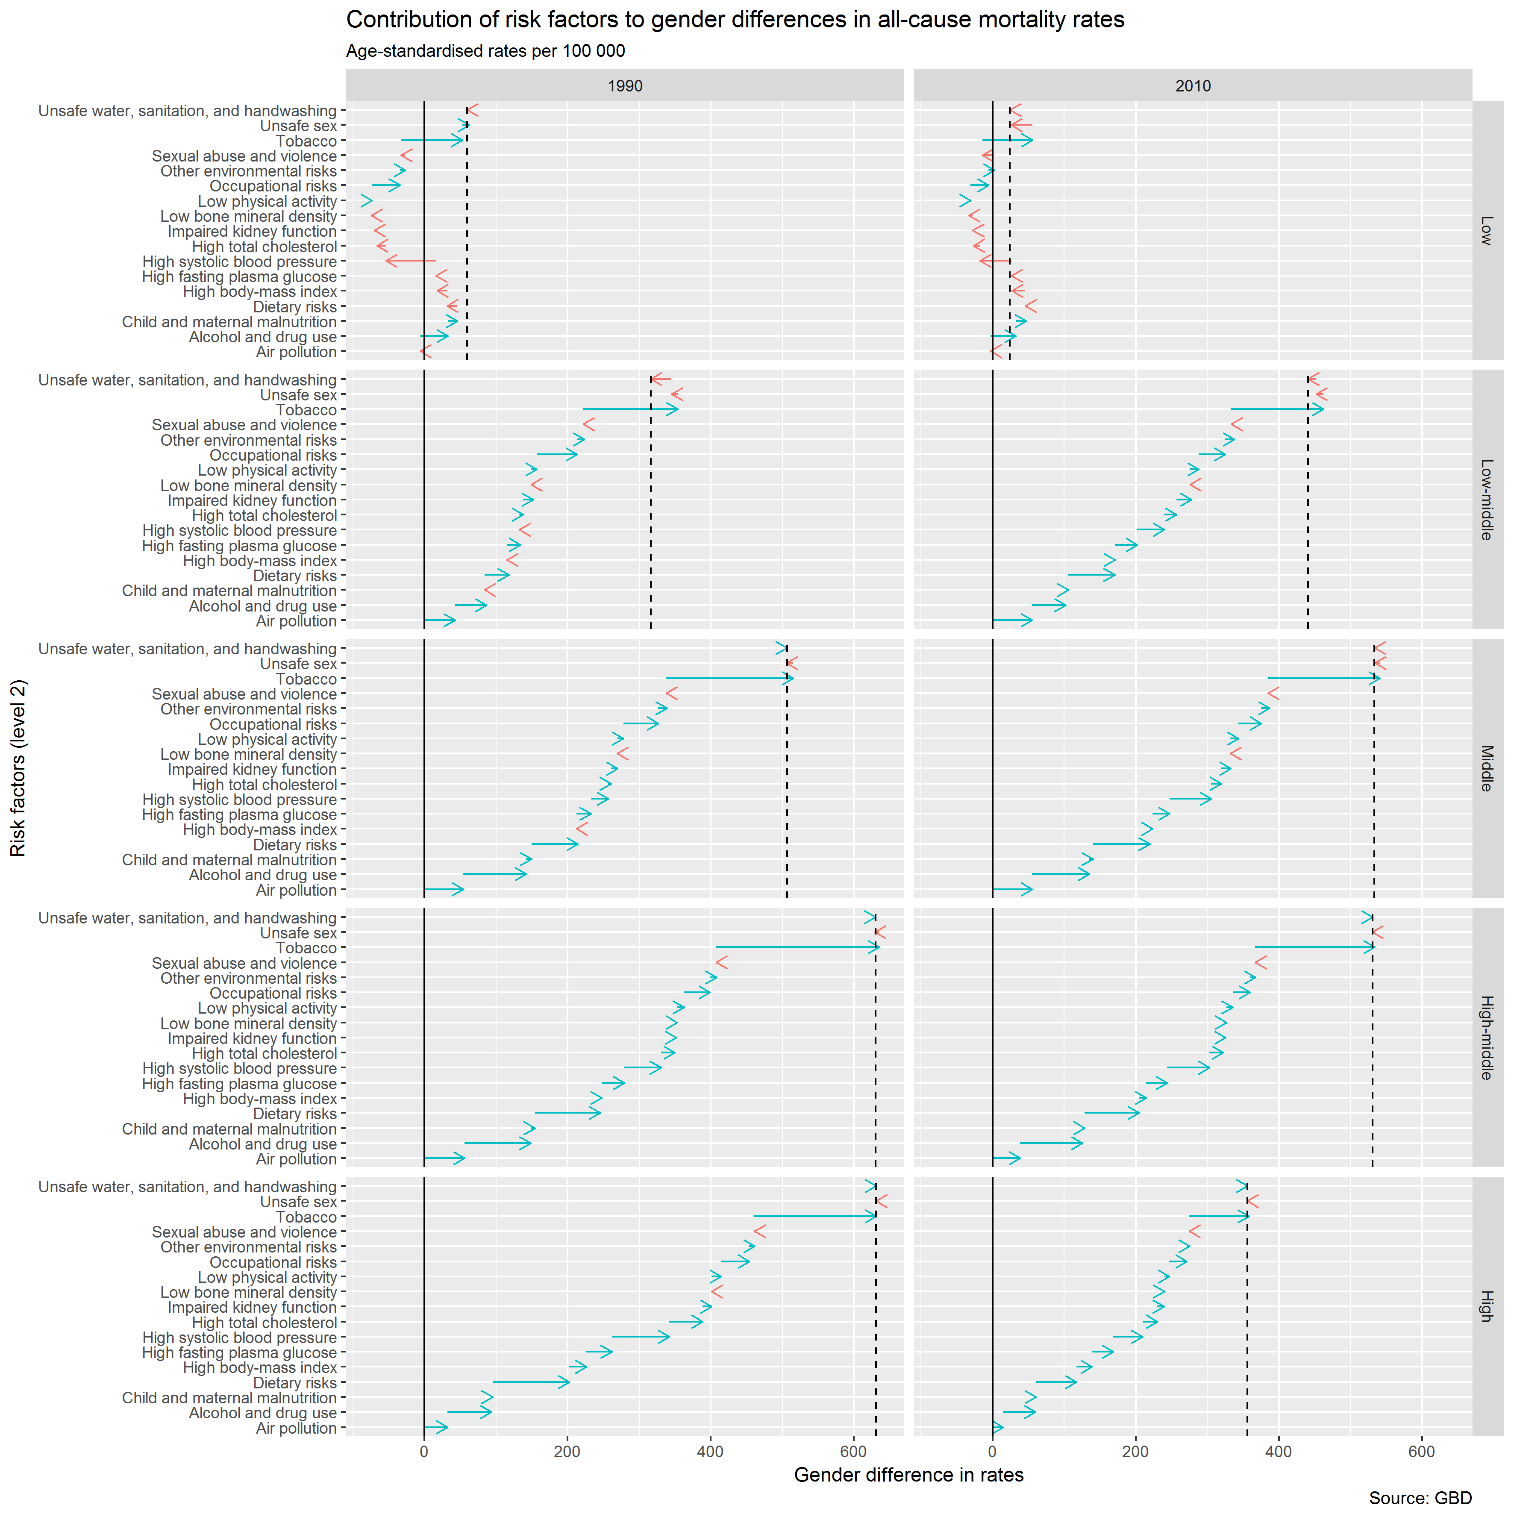

Figure 23 Decomposition of overall gender differences in age-standardised all-cause mortality rates due to level 1 risk factors, by SDI group (lowest at top, highest at bottom), in 1990 and 2010.

(Note arrow heads alone, without visible bar, indicate direction of difference, but that size of difference is relatively small in comparison with other risk factors.)

Risk factors especially relevant to NCDs:

* Alcohol & Drug Use
* Dietary Risks
* High Systolic Blood Pressure
* Tobacco Use

Note the following:

* Great fall in difference due to tobacco use in high/high-middle SDI countries.
* Falling differences overall except in middle SDI countries
* Far more risk factors > females than males in low SDI. Not in more developed countries.

Suggests the following: economic development tends first to increase gender differences in mortality risk, then to decrease. (‘Inverted tick-shaped relationship’.) Also, there have been falls in differences in exposure to affluent world risk factors (especially tobacco) over time, so reduced disparities within high(medium-high) SDI countries.

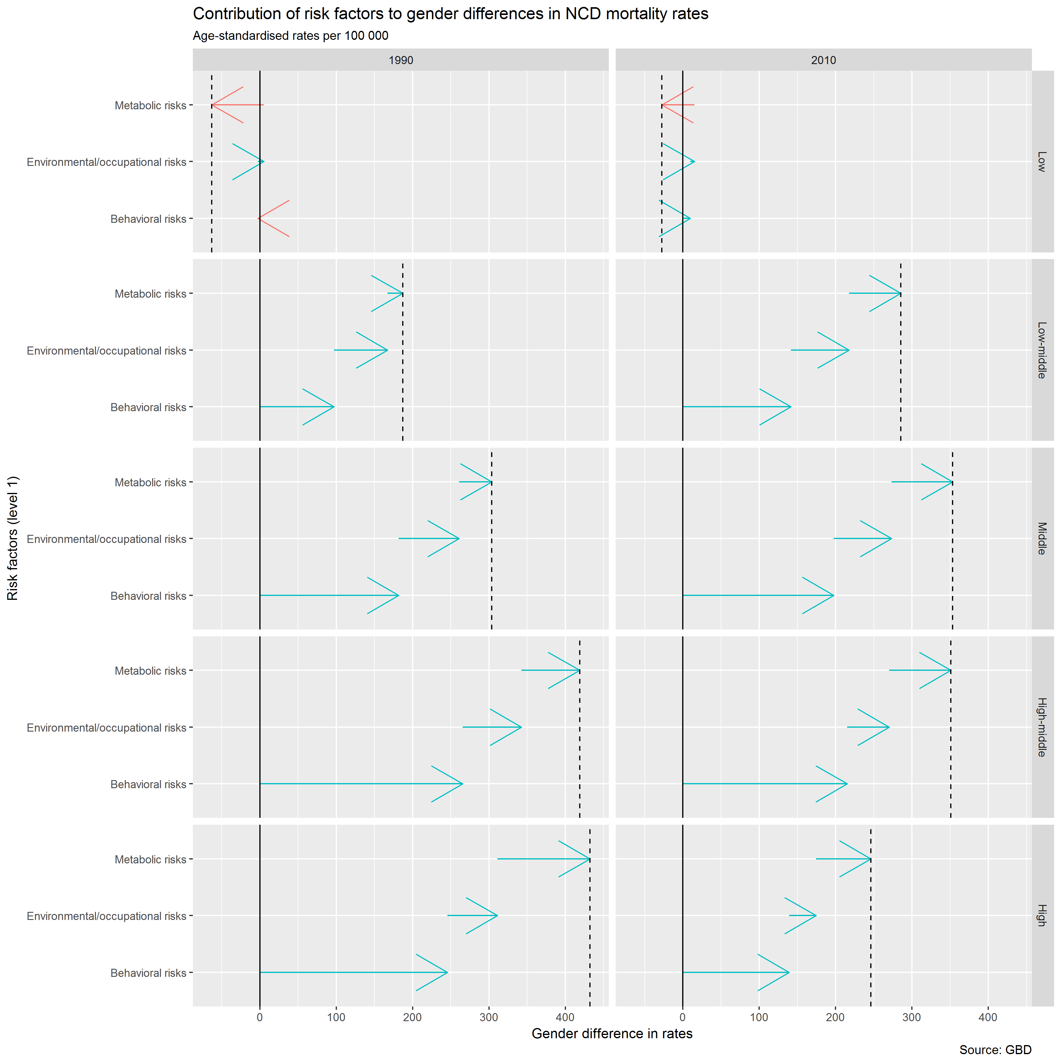

Figure 24 Decomposition of overall gender differences in age-standardised NCD mortality rates due to level 1 risk factors, by SDI group (lowest at top, highest at bottom), in 1990 and 2010.

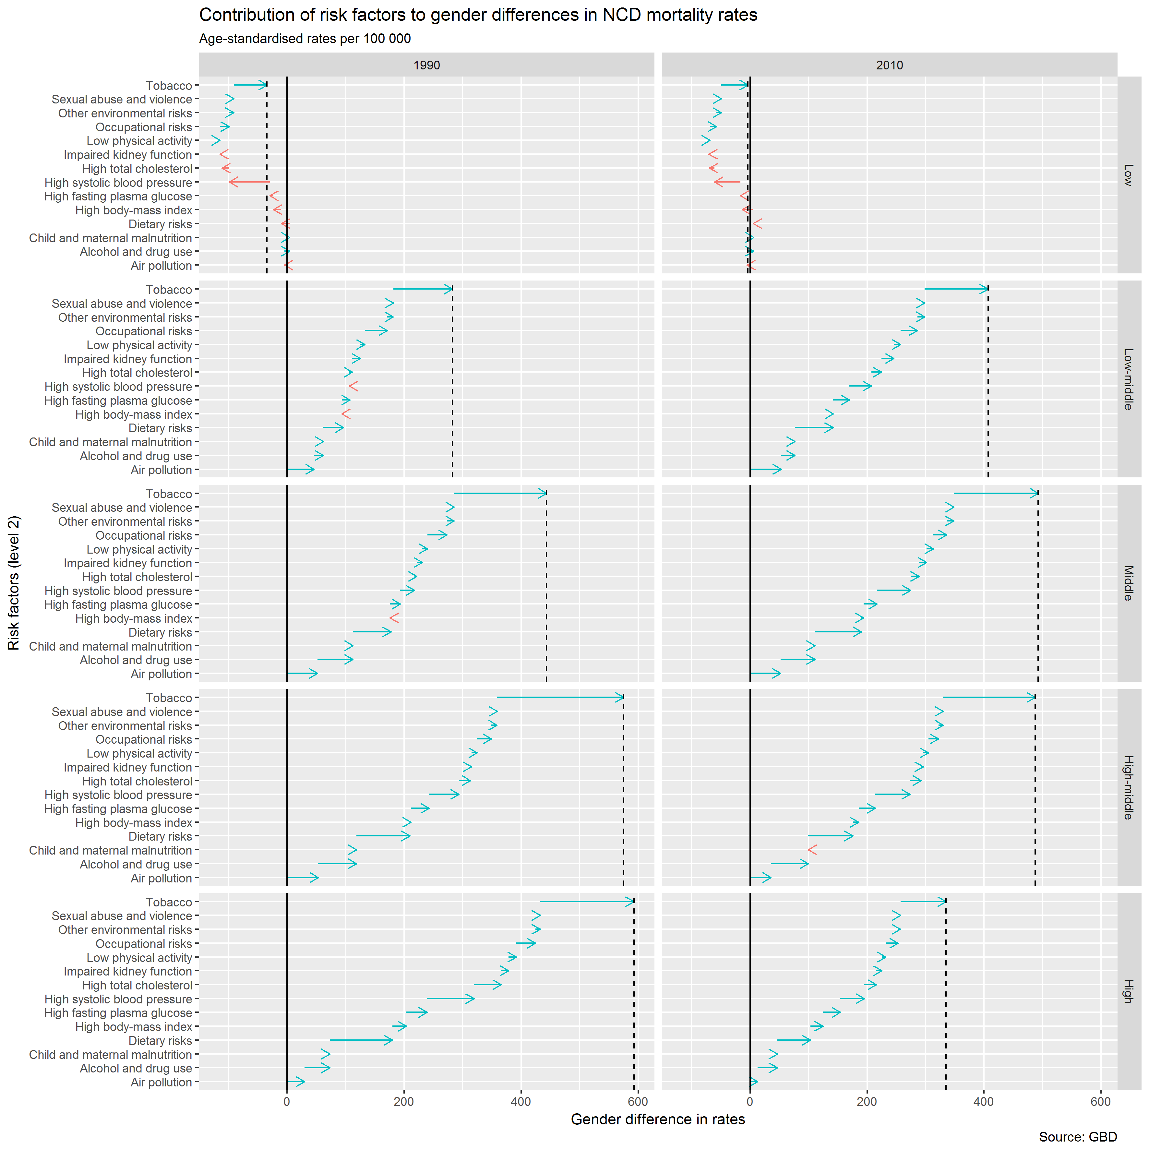

Figure 25 Decomposition of overall gender differences in age-standardised NCD mortality rates due to level 1 risk factors, by SDI group (lowest at top, highest at bottom), in 1990 and 2010.

# Indicators for consideration as exposures

The World Bank API includes nearly 17,000 indicators drawn from a wide range of source. Based on a search of key words within the descriptions, I suggest the following list of indicators:

| **indicatorID** | **indicator** | **indicatorDesc** | **sourceOrg** |
| --- | --- | --- | --- |
| UNDP.HDI.XD | Human development index (HDI) | The Human Development Index (HDI) is a summary measure of human development. It measures the average achievements in a country in three basic dimensions of human development: a long and healthy life, access to knowledge and a decent standard of living. The HDI is the geometric mean of normalized indices measuring achievements in each dimension. The HDI is the geometric mean of the three dimension indices and embodies imperfect substitutability across all HDI dimensions. It thus addresses one of the most serious criticisms of the linear aggregation formula, which allowed for perfect substitution across dimensions. Some substitutability is inherent in the definition of any index that increases with the values of its components. Data sources: Life expectancy at birth: UNDESA; Mean years of schooling: Barro and Lee; Expected years of schooling: UNESCO Institute for Statistics; Gross national income (GNI) per capita: World Bank. | http://hdr.undp.org/en/statistics/data/ |
| SL.UEM.1524.FM.ZS | Ratio of female to male youth unemployment rate (% ages 15-24) (modeled ILO estimate) | Ratio of female to male youth unemployment is the percentage of female to male youth unemployment rates. | International Labour Organization, Key Indicators of the Labour Market database. |
| SL.UEM.1524.FM.NE.ZS | Ratio of female to male youth unemployment rate (% ages 15-24) (national estimate) | Ratio of female to male youth unemployment is the percentage of female to male youth unemployment rates. | International Labour Organization, Key Indicators of the Labour Market database. |
| SH.HIV.ARTC.MA.ZS | Antiretroviral therapy coverage (% of adult males living with HIV) | The percentage of adult males living with HIV who are receiving antiretroviral therapy. | UNAIDS estimates. |
| SH.HIV.ARTC.FE.ZS | Antiretroviral therapy coverage (% of adult females living with HIV) | The percentage of adult females living with HIV who are receiving antiretroviral therapy. | UNAIDS estimates. |
| SE.NED.HIAT.MA.ZS | Educational attainment, no schooling, population 25+ years, male (%) | The percentage of population ages 25 and over that have no education. | United Nations Educational, Scientific, and Cultural Organization (UNESCO) Institute for Statistics. |
| SE.NED.HIAT.FE.ZS | Educational attainment, no schooling, population 25+ years, female (%) | The percentage of population ages 25 and over that have no education. | United Nations Educational, Scientific, and Cultural Organization (UNESCO) Institute for Statistics. |
| SE.ENR.TERT.FM.ZS | School enrollment, tertiary (gross), gender parity index (GPI) | Gender parity index for gross enrollment ratio in tertiary education is the ratio of women to men enrolled at tertiary level in public and private schools. | United Nations Educational, Scientific, and Cultural Organization (UNESCO) Institute for Statistics. |
| SE.ENR.SECO.FM.ZS | School enrollment, secondary (gross), gender parity index (GPI) | Gender parity index for gross enrollment ratio in secondary education is the ratio of girls to boys enrolled at secondary level in public and private schools. | United Nations Educational, Scientific, and Cultural Organization (UNESCO) Institute for Statistics. |
| SE.ENR.PRSC.FM.ZS | School enrollment, primary and secondary (gross), gender parity index (GPI) | Gender parity index for gross enrollment ratio in primary and secondary education is the ratio of girls to boys enrolled at primary and secondary levels in public and private schools. | United Nations Educational, Scientific, and Cultural Organization (UNESCO) Institute for Statistics. |
| SE.ENR.PRIM.FM.ZS | School enrollment, primary (gross), gender parity index (GPI) | Gender parity index for gross enrollment ratio in primary education is the ratio of girls to boys enrolled at primary level in public and private schools. | United Nations Educational, Scientific, and Cultural Organization (UNESCO) Institute for Statistics. |
| SE.ADT.1524.LT.FM.ZS | Literacy rate, youth (ages 15-24), gender parity index (GPI) | Gender parity index for youth literacy rate is the ratio of females to males ages 15-24 who can both read and write with understanding a short simple statement about their everyday life. | United Nations Educational, Scientific, and Cultural Organization (UNESCO) Institute for Statistics. |
| SP.URB.TOTL.MA.ZS | Urban population, male (% of total) | Male urban population is the percentage of males who live in urban areas to total population. | The United Nations Population Division's World Urbanization Prospects. |
| SP.URB.TOTL.FE.ZS | Urban population, female (% of total) | Female urban population is the percentage of females who live in urban areas to total population. | The United Nations Population Division's World Urbanization Prospects. |
| SG.H2O.TM30.HH.ZS | Households with water 30 minutes or longer away round trip (%) | Percentage of households who have a water source 30 minutes or longer away round trip | Demographic and Health Surveys (DHS) |
| SG.H2O.PRMS.HH.ZS | Households with water on the premises (%) | Percentage of households who have a water source on their premises | Demographic and Health Surveys (DHS) |
| SG.GEN.TECH.ZS | Female professional and technical workers (% of total) | Female professional and technical workers refers to the share of professionals and technical workers who are female. Women's share of positions are defined according to the International Standard Classification of Occupations (ISCO-88) to include physical, mathematical and engineering science professionals (and associate professionals), life science and health professionals (and associate professionals), teaching professionals (and associate professionals) and other professionals and associate professionals. | Gender, Institutions and Development Database, Organization for Economic Co-operation and Development (OECD), web site: http://www.oecd.org/document/16/0,3343,en_2649_33935_39323280_1_1_1_1,00.html. |
| SG.DMK.HLTH.HB.ZS | Decision maker about a woman's own health care: mainly husband (% of women age 15-49) | Decision maker about women own health care: mainly husband is Percentage of currently married women aged 15-49 for whom the decision maker for their own health care is mainly the husband | Demographic and Health Surveys (DHS) |
| SG.DMK.HLTH.FN.ZS | Women participating in own health care decisions (% of women age 15-49) | Women Participating in own health care decisions is Percentage of currently married women aged 15-49 who say that they alone or jointly have the final say in own health care | Demographic and Health Surveys (DHS) |
| SG.DMK.FOOD.FN.ZS | Women participating in decision of what food to cook daily (% of women age 15-49) | Women participating in decision of what food to cook daily is Percentage of currently married women aged 15-49 who say that they alone or jointly have the final say in what food to cook daily | Demographic and Health Surveys (DHS) |
| SG.DMK.DPCH.FN.ZS | Women participating in making daily purchase decisions (% of women age 15-49) | Women participating in making daily purchase decisions is Percentage of currently married women aged 15-49 who say that they alone or jointly have the final say in making daily purchases | Demographic and Health Surveys (DHS) |
| SG.CRT.TSTM.WT | Woman's testimony carries the same evidentiary weight in court as a man's (1=yes; 0=no) | Woman's testimony carries the same evidentiary weight in court as a man's is whether the law differentiates between the evidentiary value of a woman’s testimony in a court and that of a man. It covers all types of court cases. | NA |
| SG.COK.OUTD.ZS | Location of cooking: outdoors (% of households) | Percentage of households who do their cooking outdoors | Demographic and Health Surveys (DHS) |
| SG.COK.ELEC.ZS | Main cooking fuel: electricity (% of households) | Percentage of households who use electricity as thier main cooking fuel | Demographic and Health Surveys (DHS) |
| 5.51.01.07.gender | Gender equality | The indicator is defined as the ratio of the gross enrollment rate of girls to boys in primary and secondary education levels in both public and private schools. Women have an enormous impact on the well-being of their families and societies, but their potential is sometimes not realized because of discriminatory social norms, incentives, and legal institutions. Although their status has improved in recent decades, gender inequalities persist. Education is one of the most important aspects of human development, and eliminating gender disparity at all levels of education would help to increase the status and capabilities of women. This indicator provides a measure of equality of educational opportunity and relates to the third MDG that seeks to promote gender equality and the empowerment of women. | World Development Indicator (WDI) databank. Original source: UNESCO Institute for Statistics: Table 5: Enrolment ratios by ISCED level |
| MO.INDEX.XQ | Overall Mo Ibrahim index | Measures overall index on (a) Safety and rule of law (b) Participation and human rights (c) Sustainable Economic opportunity and (d) Human development. | Mo Ibrahim Foundation, electronic files and web site. |

The full list of indicators is provided in the document ‘all_wb_indicators.xlsx’. Columns H onwards indicate the key words that have been searched for, and the rows can be filtered on these indicators.